Project Report : Code for 14 tables creation -- Department table

CREATE TABLE IF NOT EXISTS Department (

DepartmentID INT AUTO_INCREMENT PRIMARY KEY,

DepartmentName VARCHAR(100),

Location VARCHAR(100)

);

-- Faculty table

CREATE TABLE IF NOT EXISTS Faculty (

FacultyID INT AUTO_INCREMENT PRIMARY KEY,

FacultyName VARCHAR(100),

FacultyEmail VARCHAR(100),

FacultyPhone VARCHAR(20),

DepartmentID INT,

FOREIGN KEY (DepartmentID) REFERENCES Department(DepartmentID)

);

-- Report table

CREATE TABLE IF NOT EXISTS Report (

ReportID INT AUTO_INCREMENT PRIMARY KEY,

ReportContent TEXT,

Status VARCHAR(50)

);

-- Reviewer table

CREATE TABLE IF NOT EXISTS Reviewer (

ReviewerID INT AUTO_INCREMENT PRIMARY KEY,

ReviewerName VARCHAR(100),

ReviewerEmail VARCHAR(100)

);

-- ReportingPeriod table

CREATE TABLE IF NOT EXISTS ReportingPeriod (

ReportingPeriodID INT AUTO_INCREMENT PRIMARY KEY,

PeriodStart DATE,

PeriodEnd DATE

);

-- DisbursementMethod table

CREATE TABLE IF NOT EXISTS DisbursementMethod (

MethodID INT AUTO_INCREMENT PRIMARY KEY,

MethodName VARCHAR(100)

);

-- Award table

CREATE TABLE IF NOT EXISTS Award (

AwardID INT AUTO_INCREMENT PRIMARY KEY,

Name VARCHAR(100)

);

-- Institution table

CREATE TABLE IF NOT EXISTS Institution (

InstitutionID INT AUTO_INCREMENT PRIMARY KEY,

InstitutionName VARCHAR(100)

);

-- Student table

CREATE TABLE IF NOT EXISTS Student (

StudentID INT AUTO_INCREMENT PRIMARY KEY,

StudentName VARCHAR(100),

StudentAddress VARCHAR(200),

StudentEmail VARCHAR(100),

DepartmentID INT,

FOREIGN KEY (DepartmentID) REFERENCES Department(DepartmentID)

);

CREATE TABLE IF NOT EXISTS Scholarship (

ScholarshipID INT AUTO_INCREMENT PRIMARY KEY,

AwardID INT,

InstitutionID INT,

Amount DECIMAL(10, 2),

FOREIGN KEY (AwardID) REFERENCES Award(AwardID),

FOREIGN KEY (InstitutionID) REFERENCES Institution(InstitutionID)

);

-- Application table

CREATE TABLE IF NOT EXISTS Application (

ApplicationID INT AUTO_INCREMENT PRIMARY KEY,

StudentID INT,

ScholarshipID INT,

ApplicationStatus VARCHAR(50),

FOREIGN KEY (StudentID) REFERENCES Student(StudentID),

FOREIGN KEY (ScholarshipID) REFERENCES Scholarship(ScholarshipID)

);

-- Criteria table

CREATE TABLE IF NOT EXISTS Criteria (

CriteriaID INT AUTO_INCREMENT PRIMARY KEY,

ScholarshipID INT,

Description TEXT,

FOREIGN KEY (ScholarshipID) REFERENCES Scholarship(ScholarshipID)

);

-- Review table

CREATE TABLE IF NOT EXISTS Review (

ReviewID INT AUTO_INCREMENT PRIMARY KEY,

ScholarshipID INT,

ApplicationID INT,

ReviewerID INT,

ReportID INT,

Status VARCHAR(50),

FOREIGN KEY (ScholarshipID) REFERENCES Scholarship(ScholarshipID),

FOREIGN KEY (ApplicationID) REFERENCES Application(ApplicationID),

FOREIGN KEY (ReviewerID) REFERENCES Reviewer(ReviewerID),

FOREIGN KEY (ReportID) REFERENCES Report(ReportID)

);

-- Disbursement table

CREATE TABLE IF NOT EXISTS Disbursement (

DisbursementID INT AUTO_INCREMENT PRIMARY KEY,

StudentID INT,

CriteriaID INT,

Amount DECIMAL(10, 2),

ReportingPeriodID INT,

FOREIGN KEY (StudentID) REFERENCES Student(StudentID),

FOREIGN KEY (CriteriaID) REFERENCES Criteria(CriteriaID),

);

Screenshots for Table creation:

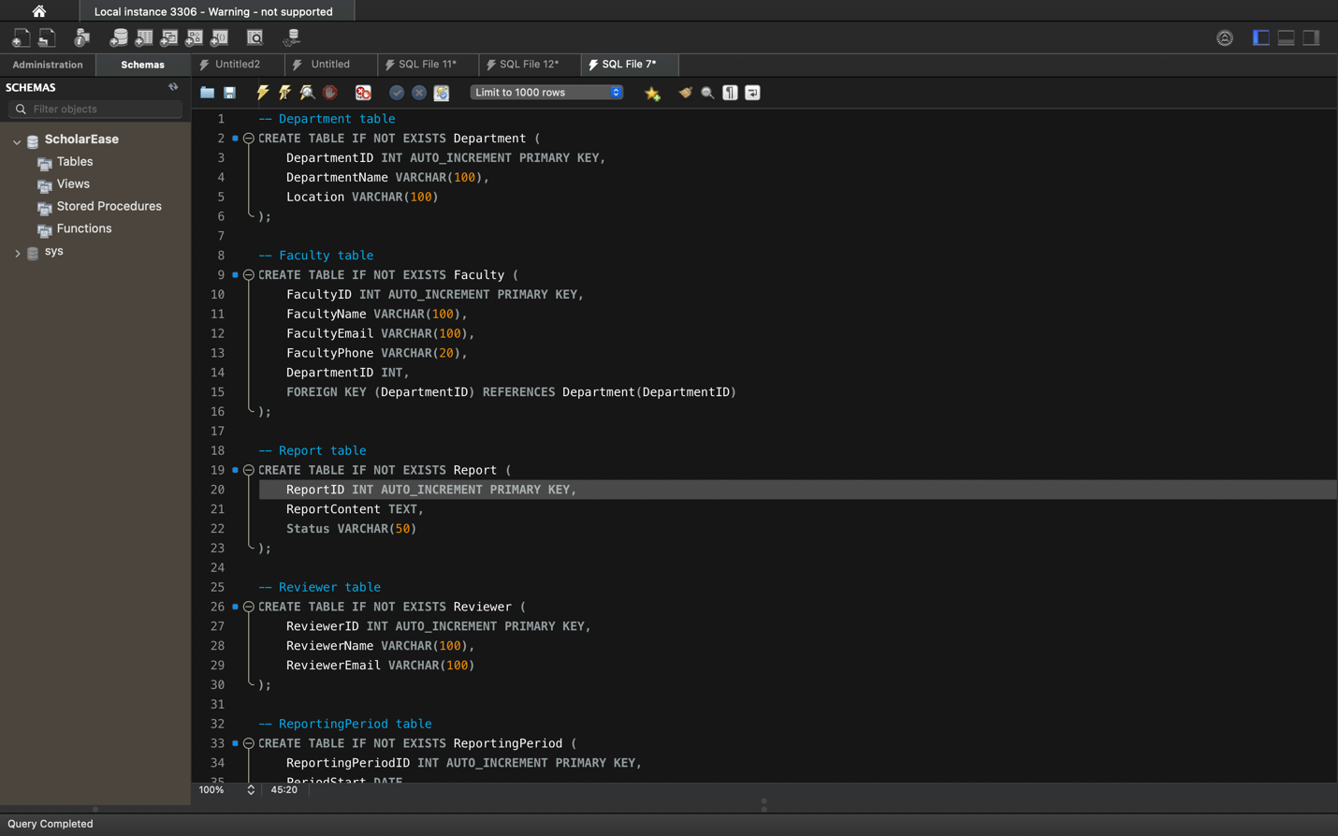

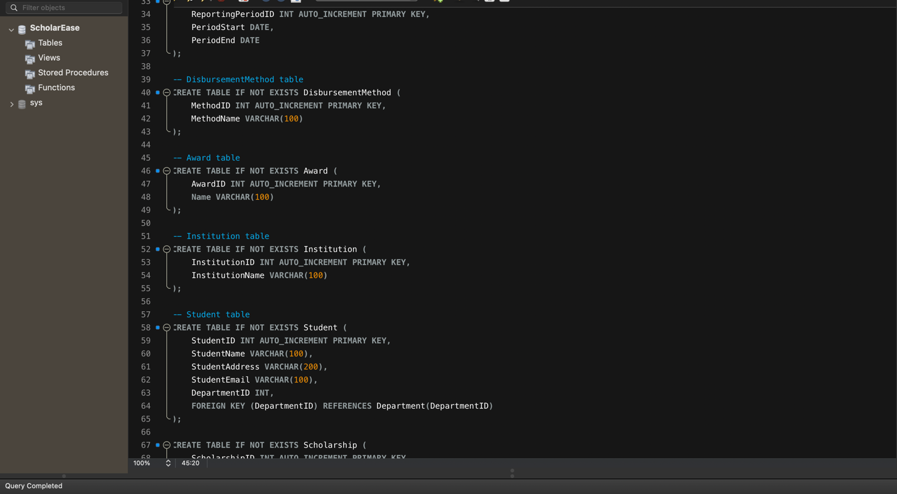

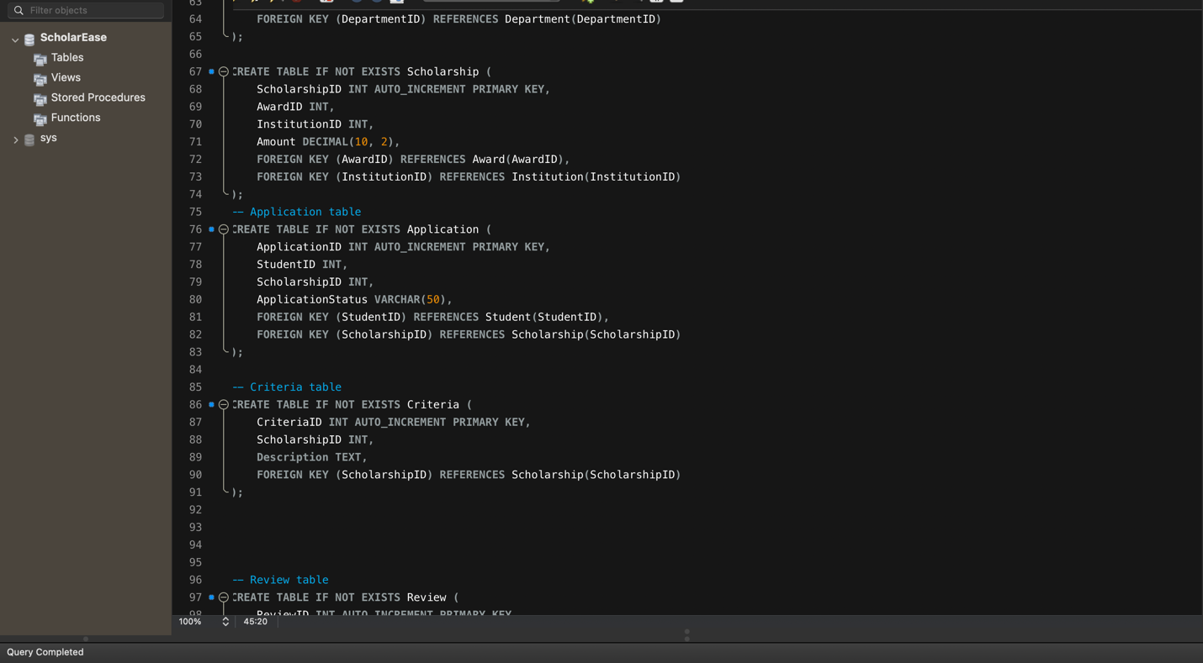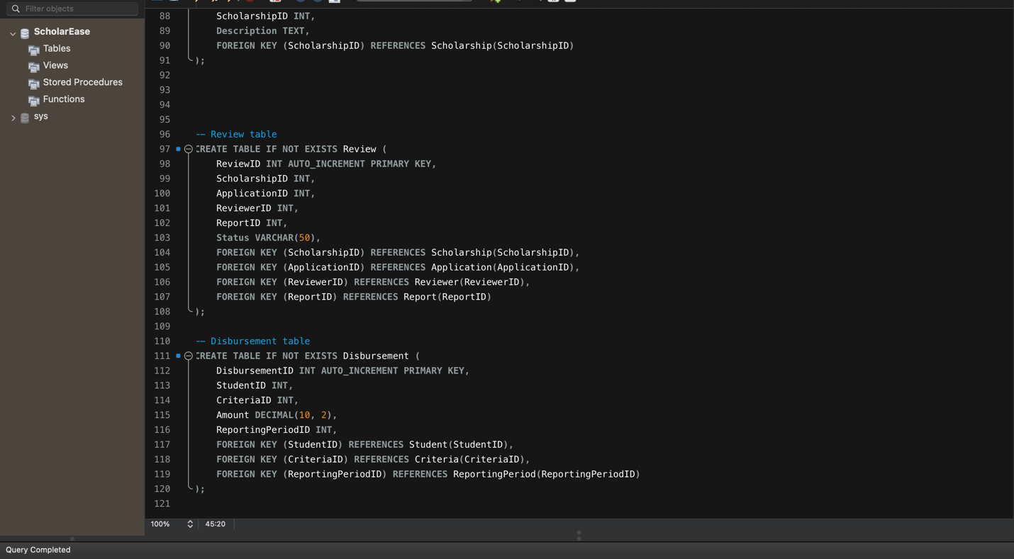

Inserting Data into Each table: INSERT INTO Department (DepartmentName, Location)

VALUES

('Computer Science', 'Science Building'),

('Engineering', 'Engineering Building'),

('Mathematics', 'Mathematics Building'),

('Physics', 'Physics Building'),

('Chemistry', 'Chemistry Building'),

('Biology', 'Biology Building'),

('English', 'English Building'),

('History', 'History Building'),

('Psychology', 'Psychology Building'),

('Sociology', 'Sociology Building'),

('Economics', 'Economics Building'),

('Business Administration', 'Business Building'),

('Music', 'Music Building'),

('Art', 'Art Building'),

('Theatre Arts', 'Theatre Building'),

('Dance', 'Dance Building'),

('Education', 'Education Building'),

('Kinesiology', 'Kinesiology Building'),

('Health Sciences', 'Health Sciences Building'),

('Information Science', 'Information Science Building'),

('Library Science', 'Library Science Building'),

('Political Science', 'Political Science Building'),

('Communication Studies', 'Communication Building'),

('Geography', 'Geography Building'),

('Philosophy', 'Philosophy Building'),

('Religious Studies', 'Religious Studies Building'),

('Public Administration', 'Public Administration Building'),

('Nutrition', 'Nutrition Building'),

('Environmental Science', 'Environmental Science Building');

Department Table 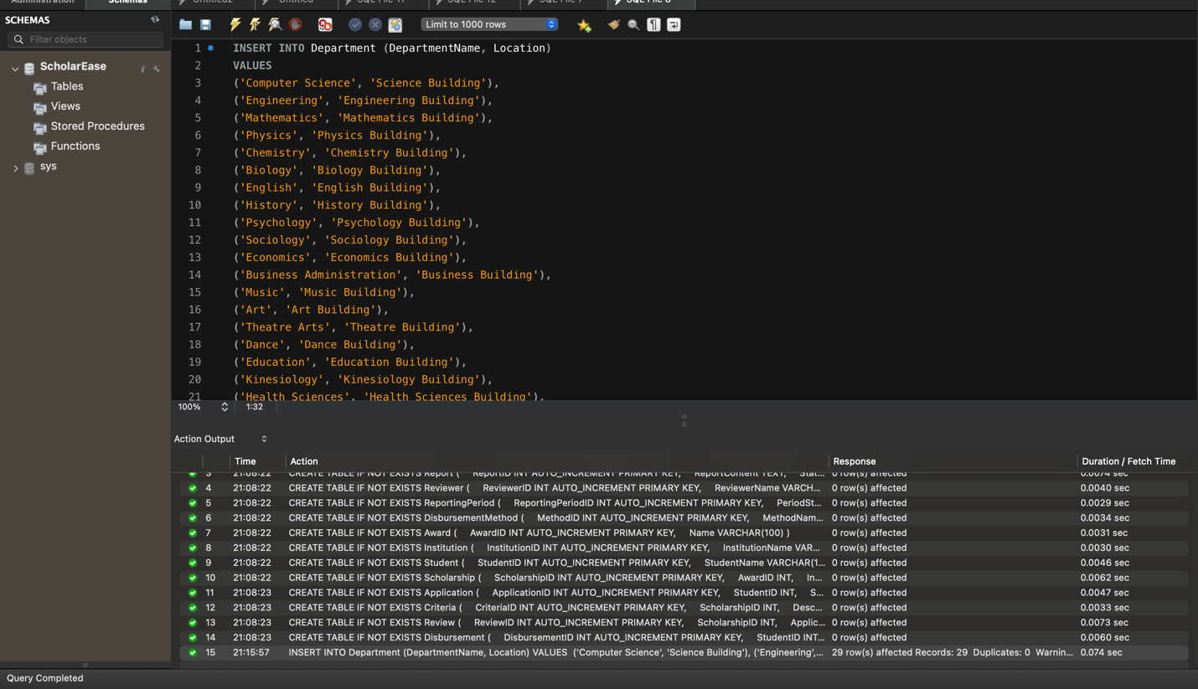

Displaying the Data:

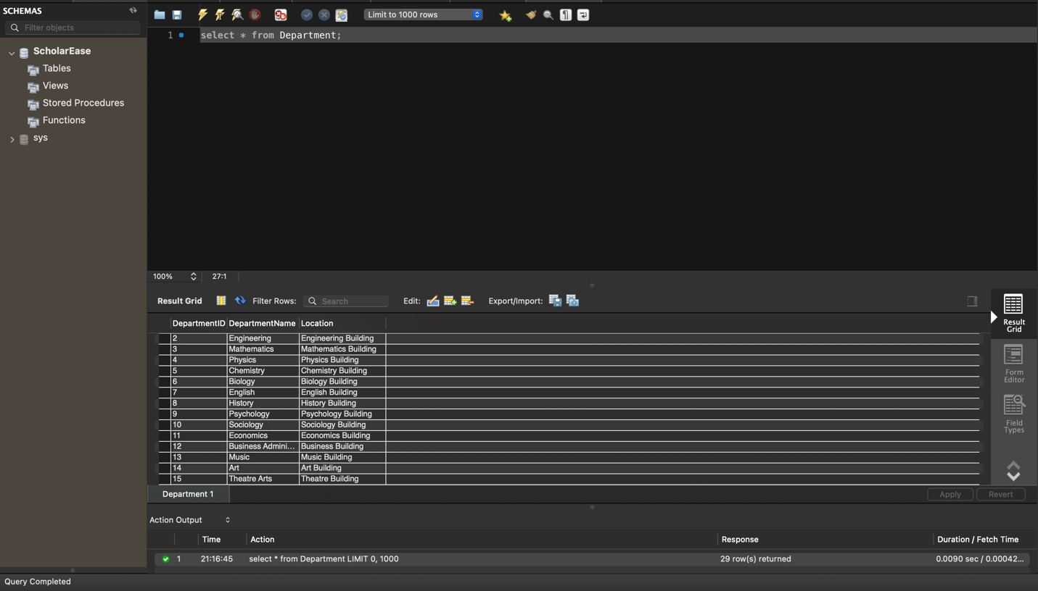

Faculty Table: INSERT INTO Faculty (FacultyName, FacultyEmail, FacultyPhone, DepartmentID)

VALUES

('John Smith', 'jsmith@unt.edu', '123-456-7890', 1),

('Emily Johnson', 'ejohnson@unt.edu', '234-567-8901', 1),

('Michael Williams', 'mwilliams@unt.edu', '345-678-9012', 2),

('Jessica Brown', 'jbrown@unt.edu', '456-789-0123', 2),

('David Jones', 'djones@unt.edu', '567-890-1234', 3),

('Jennifer Davis', 'jdavis@unt.edu', '678-901-2345', 3),

('Christopher Miller', 'cmiller@unt.edu', '789-012-3456', 4),

('Sarah Wilson', 'swilson@unt.edu', '890-123-4567', 4),

('Matthew Moore', 'mmoore@unt.edu', '901-234-5678', 5),

('Amanda Taylor', 'ataylor@unt.edu', '012-345-6789', 5),

('Robert Anderson', 'randerson@unt.edu', '123-456-7890', 6),

('Stephanie Martinez', 'smartinez@unt.edu', '234-567-8901', 6),

('William Jackson', 'wjackson@unt.edu', '345-678-9012', 7),

('Lauren White', 'lwhite@unt.edu', '456-789-0123', 7),

('Daniel Harris', 'dharris@unt.edu', '567-890-1234', 8),

('Karen Thompson', 'kthompson@unt.edu', '678-901-2345', 8),

('Richard Garcia', 'rgarcia@unt.edu', '789-012-3456', 9),

('Ashley Martinez', 'amartinez@unt.edu', '890-123-4567', 9),

('James Robinson', 'jrobinson@unt.edu', '901-234-5678', 10),

('Melissa Lee', 'mlee@unt.edu', '012-345-6789', 10),

('Daniel Clark', 'dclark@unt.edu', '123-456-7890', 11),

('Rebecca Wright', 'rwright@unt.edu', '234-567-8901', 11),

('Jonathan King', 'jking@unt.edu', '345-678-9012', 12),

('Rachel Scott', 'rscott@unt.edu', '456-789-0123', 12),

('Justin Adams', 'jadams@unt.edu', '567-890-1234', 13),

('Natalie Hill', 'nhill@unt.edu', '678-901-2345', 13),

('Brandon Young', 'byoung@unt.edu', '789-012-3456', 14),

('Kelly Rodriguez', 'krodriguez@unt.edu', '890-123-4567', 14),

('Erica Martinez', 'emartinez@unt.edu', '901-234-5678', 15),

('Timothy Hall', 'thall@unt.edu', '012-345-6789', 15);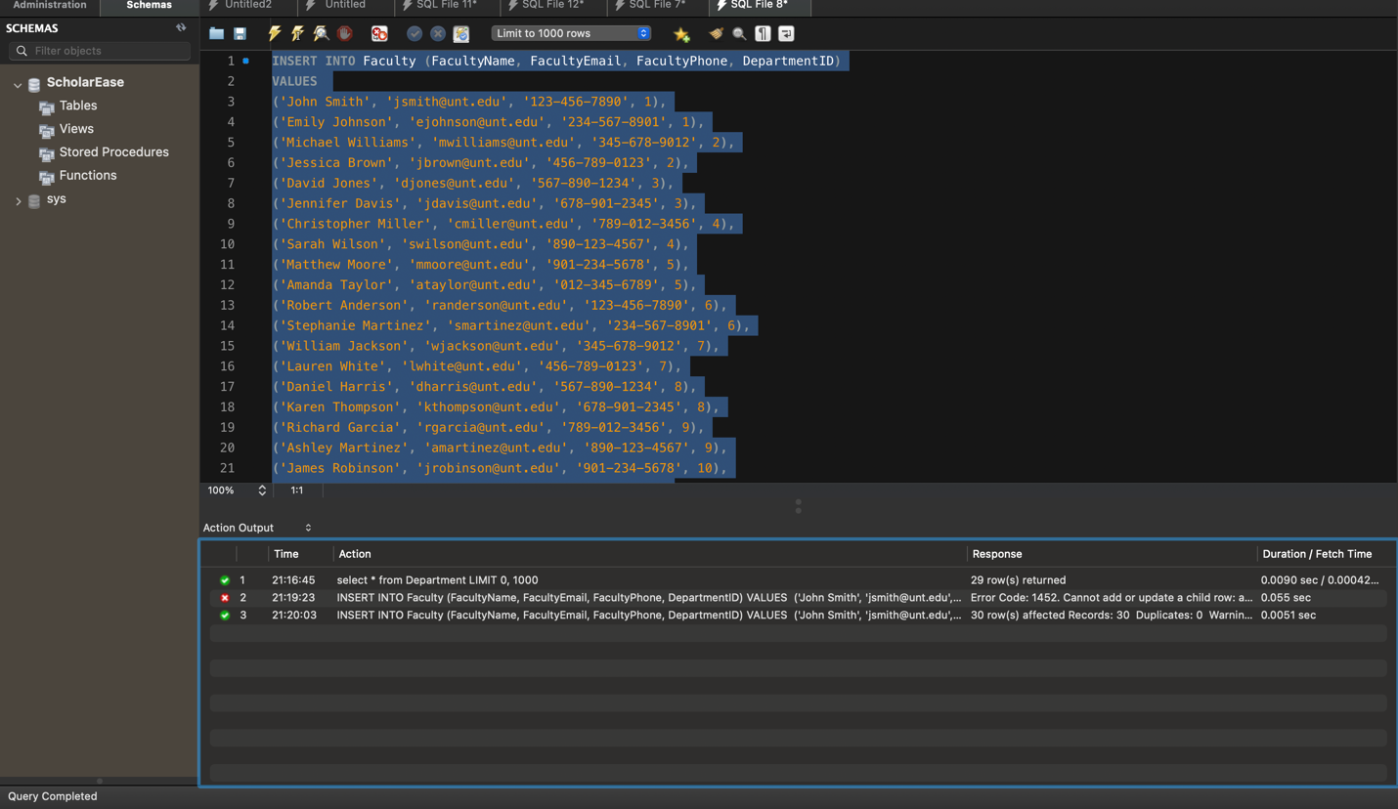

Displaying the data: 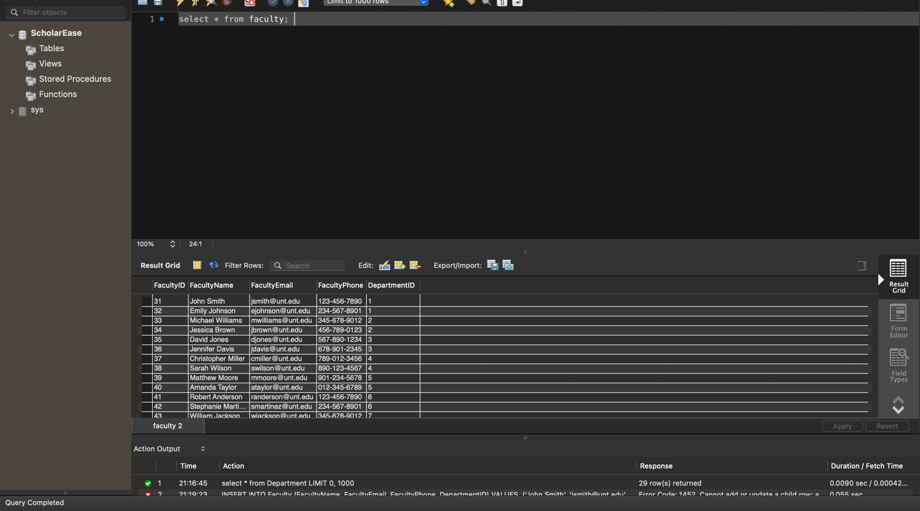

**Report:**

INSERT INTO Report (ReportContent, Status) VALUES

('The scholarship application has been reviewed and meets all criteria.', 'Approved'),

('Additional documentation is required to process the scholarship application.', 'Pending'),

('The scholarship committee has identified the recipient based on academic merit.', 'Approved'),

('A decision on the scholarship application is pending further review.', 'Pending'),

('The scholarship interview process has been completed successfully.', 'Approved'),

('The scholarship funds have been disbursed to the recipient.', 'Approved'),

('The scholarship application deadline has been extended due to unforeseen circumstances.', 'Pending'),

('The scholarship selection process is underway, and applicants will be notified soon.', 'Pending'),

('An error in the scholarship application has been identified and corrected.', 'Pending'),

('The scholarship recipient has been notified and is required to submit acceptance documentation.', 'Pending'),

('The scholarship committee is reviewing applications for financial need-based awards.', 'Approved'),

('Scholarship recipients will be announced at the upcoming awards ceremony.', 'Pending'),

('The scholarship essay submissions demonstrate creativity and originality.', 'Approved'),

('The scholarship application review process is proceeding as planned.', 'Pending'),

('The scholarship committee is evaluating candidates for the leadership scholarship.', 'Approved'),

('The scholarship application portal is temporarily unavailable due to system maintenance.', 'Pending'),

('Scholarship eligibility criteria have been updated to reflect changes in funding.', 'Approved'),

('The scholarship application pool has been narrowed down to final candidates for consideration.', 'Pending'),

('The scholarship award amount has been adjusted to ensure equitable distribution.', 'Approved'),

('The scholarship selection process has been delayed due to unforeseen circumstances.', 'Pending'),

('The scholarship recipient has provided proof of enrollment and eligibility.', 'Approved'),

('The scholarship committee is reviewing applications for academic achievement awards.', 'Pending'),

('Scholarship disbursement has been delayed pending final approval from the funding source.', 'Pending'),

('The scholarship recipient has been selected based on demonstrated financial need.', 'Approved'),

('The scholarship application review process has been completed ahead of schedule.', 'Approved'),

('The scholarship recipient has been chosen based on their commitment to community service.', 'Approved'),

('The scholarship committee is evaluating candidates for the STEM scholarship.', 'Pending'),

('Scholarship recipients are required to attend an orientation session prior to disbursement.', 'Pending'),

('The scholarship application portal has been updated with additional resources for applicants.', 'Approved'),

('The scholarship committee is reviewing applications for the need-based scholarship.', 'Pending');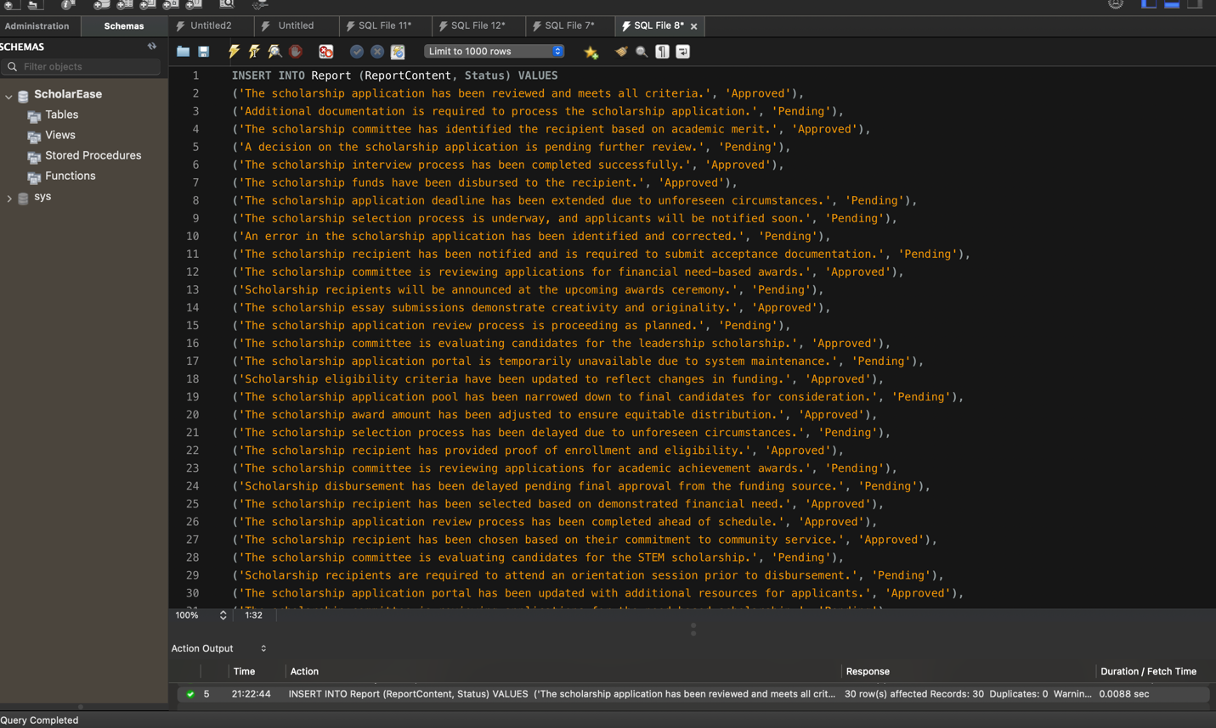

Displaying the Data: 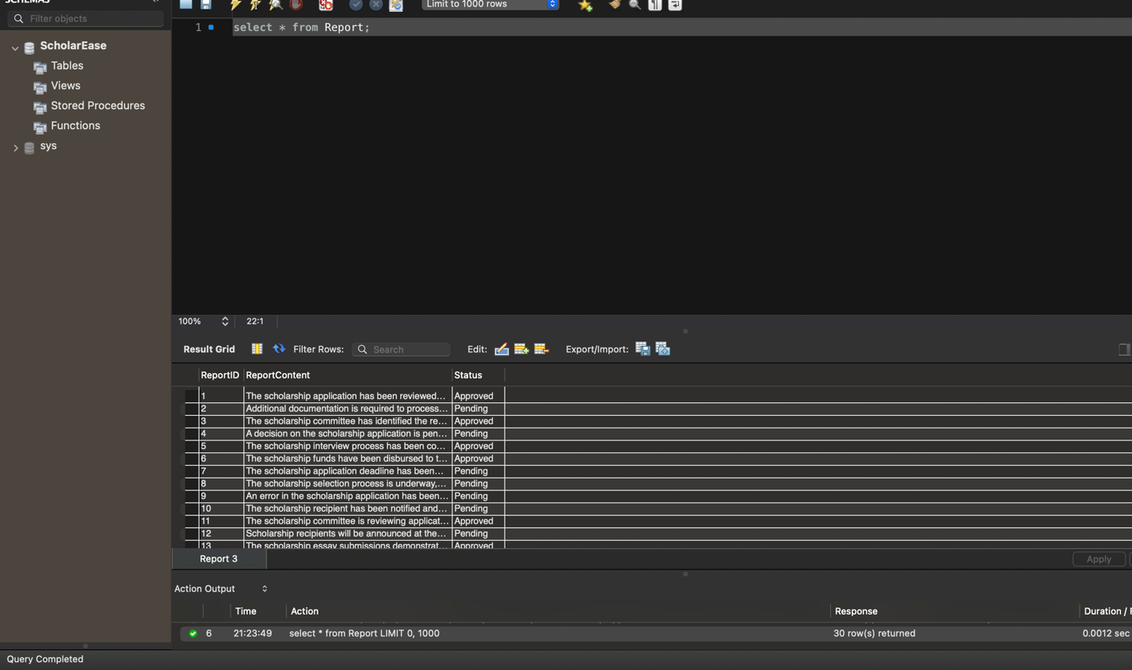

Reviewer Table : INSERT INTO Reviewer (ReviewerName, ReviewerEmail) VALUES

('John Smith', 'john.smith@example.com'),

('Emily Johnson', 'emily.johnson@example.com'),

('Michael Brown', 'michael.brown@example.com'),

('Jessica Davis', 'jessica.davis@example.com'),

('Christopher Wilson', 'christopher.wilson@example.com'),

('Jennifer Taylor', 'jennifer.taylor@example.com'),

('Matthew Martinez', 'matthew.martinez@example.com'),

('Amanda Anderson', 'amanda.anderson@example.com'),

('Daniel Thomas', 'daniel.thomas@example.com'),

('Sarah Garcia', 'sarah.garcia@example.com'),

('Robert Rodriguez', 'robert.rodriguez@example.com'),

('Melissa Martinez', 'melissa.martinez@example.com'),

('David Hernandez', 'david.hernandez@example.com'),

('Jennifer Wright', 'jennifer.wright@example.com'),

('Brian Lopez', 'brian.lopez@example.com'),

('Jessica Hill', 'jessica.hill@example.com'),

('William Young', 'william.young@example.com'),

('Laura Lee', 'laura.lee@example.com'),

('Kevin Scott', 'kevin.scott@example.com'),

('Maria King', 'maria.king@example.com'),

('James Campbell', 'james.campbell@example.com'),

('Mary Hall', 'mary.hall@example.com'),

('Richard Green', 'richard.green@example.com'),

('Stephanie Baker', 'stephanie.baker@example.com'),

('Andrew Perez', 'andrew.perez@example.com'),

('Patricia Adams', 'patricia.adams@example.com'),

('Mark Evans', 'mark.evans@example.com'),

('Jennifer Torres', 'jennifer.torres@example.com'),

('Jason Morris', 'jason.morris@example.com');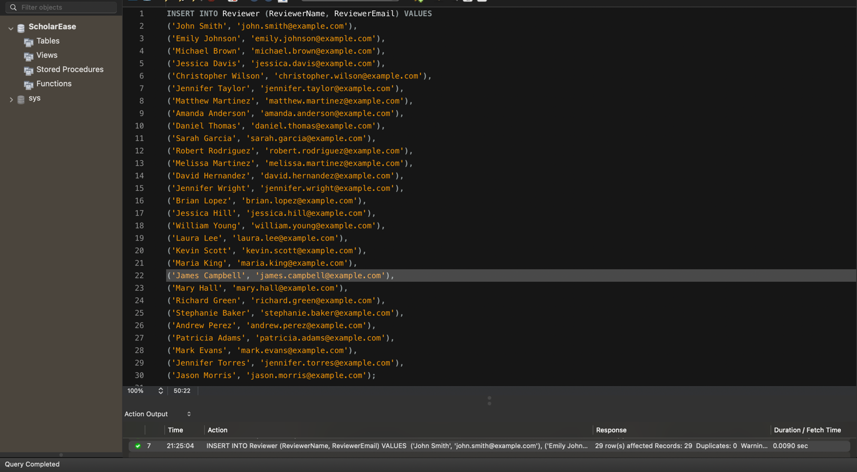

Displaying the data: 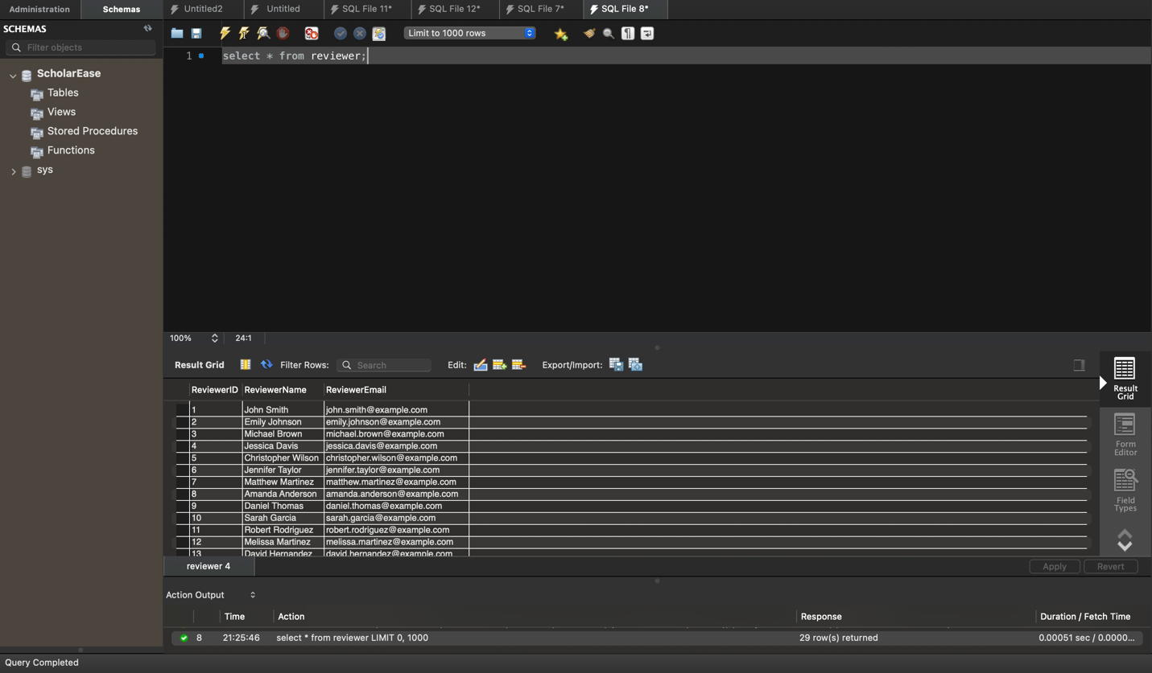

Reporting Period : INSERT INTO ReportingPeriod (PeriodStart, PeriodEnd) VALUES

('2020-01-01', '2020-05-15'), -- Spring 2020

('2020-05-16', '2020-08-15'), -- Summer 2020

('2020-08-16', '2020-12-31'), -- Fall 2020

('2021-01-01', '2021-05-15'), -- Spring 2021

('2021-05-16', '2021-08-15'), -- Summer 2021

('2021-08-16', '2021-12-31'), -- Fall 2021

('2022-01-01', '2022-05-15'), -- Spring 2022

('2022-05-16', '2022-08-15'), -- Summer 2022

('2022-08-16', '2022-12-31'), -- Fall 2022

('2023-01-01', '2023-05-15'), -- Spring 2023

('2023-05-16', '2023-08-15'), -- Summer 2023

('2023-08-16', '2023-12-31'), -- Fall 2023

('2024-01-01', '2024-05-15'), -- Spring 2024

('2024-05-16', '2024-08-15'), -- Summer 2024

('2024-08-16', '2024-12-31'); -- Fall 2024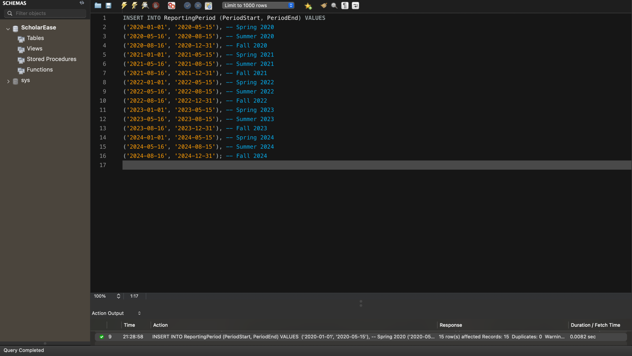

Displaying the data :

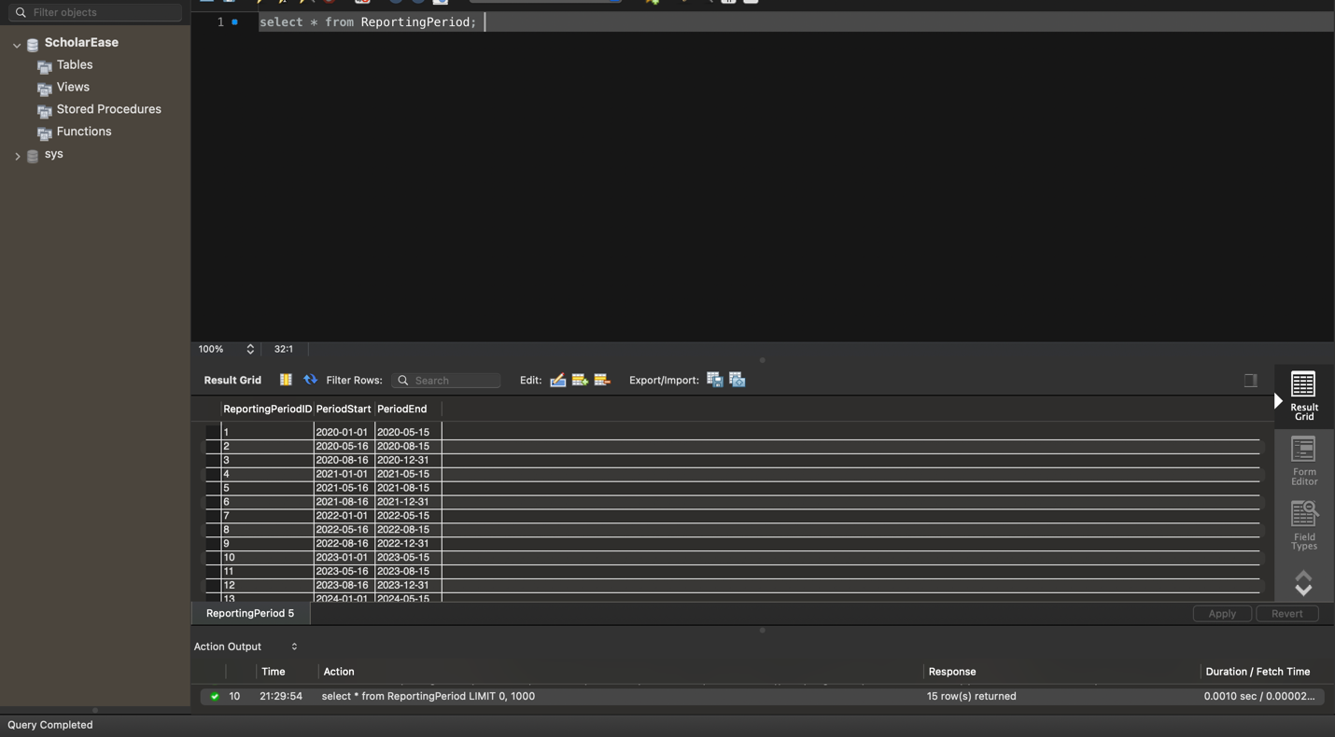

Disbursement Method: INSERT INTO DisbursementMethod (MethodName) VALUES

('Direct Deposit'),

('Check'),

('Bank Transfer'),

('Cash'),

('PayPal'),

('Wire Transfer'),

('Venmo'),

('Cash App'),

('Zelle'),

('Money Order');

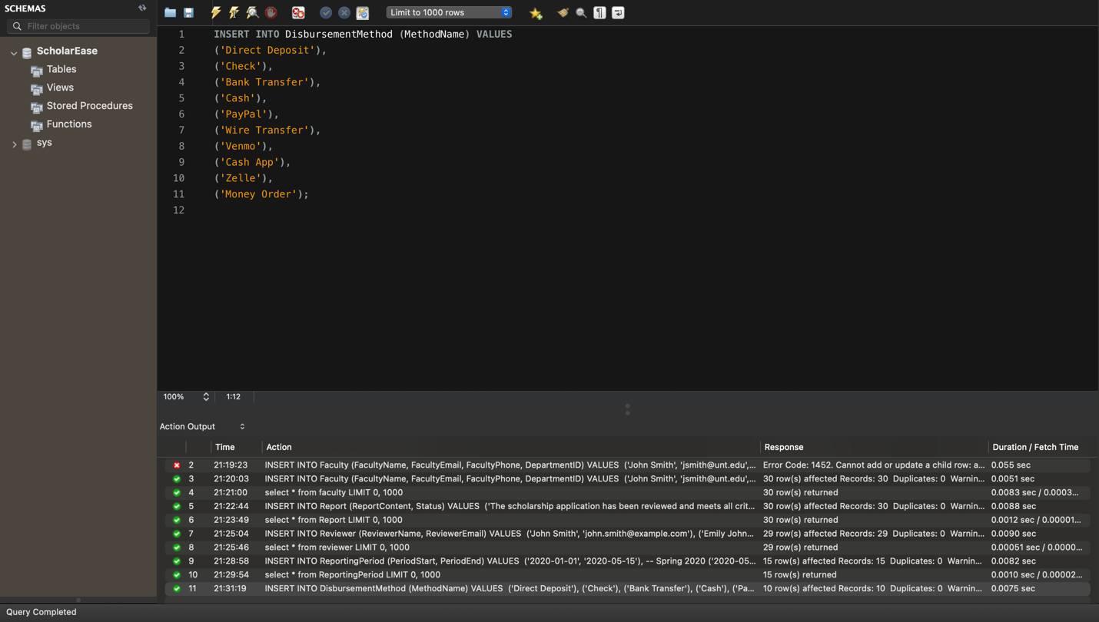

Displying the data :

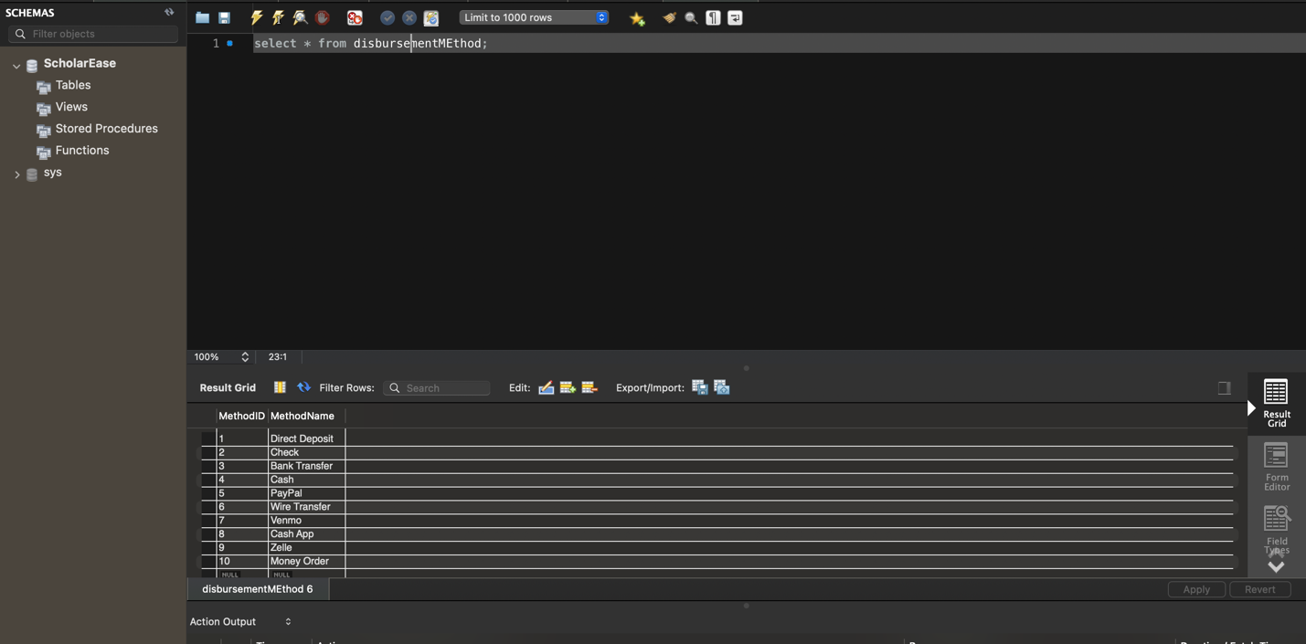

Award Table: INSERT INTO Award (Name) VALUES

('Merit Scholarship'),

('Need-Based Scholarship'),

('STEM Scholarship'),

('Athletic Scholarship'),

('Fine Arts Scholarship'),

('Leadership Scholarship'),

('Community Service Scholarship'),

('First-Generation Scholarship'),

('Diversity Scholarship'),

('Academic Achievement Scholarship');

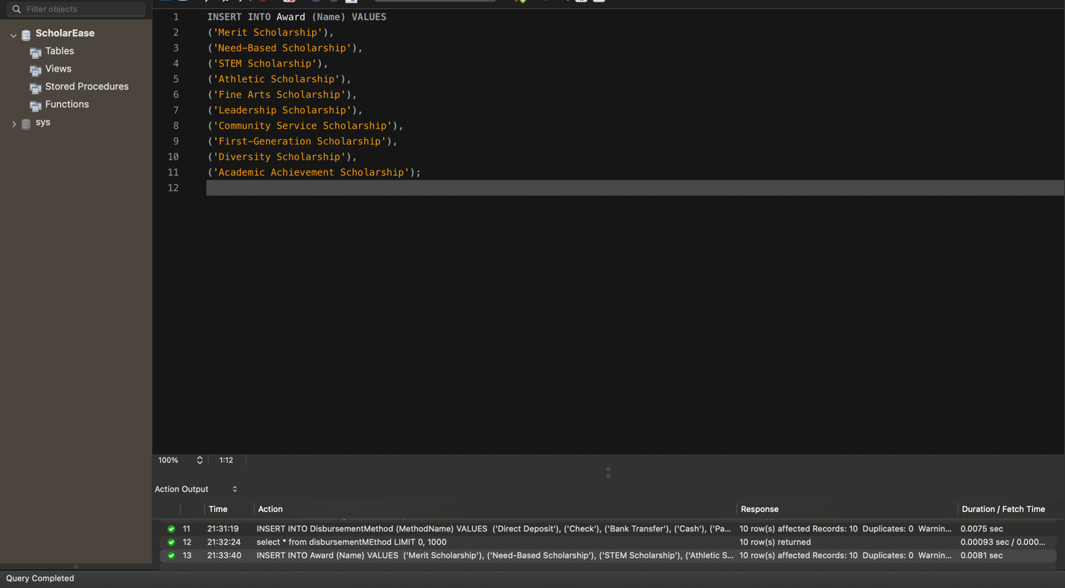

Displaying the data: 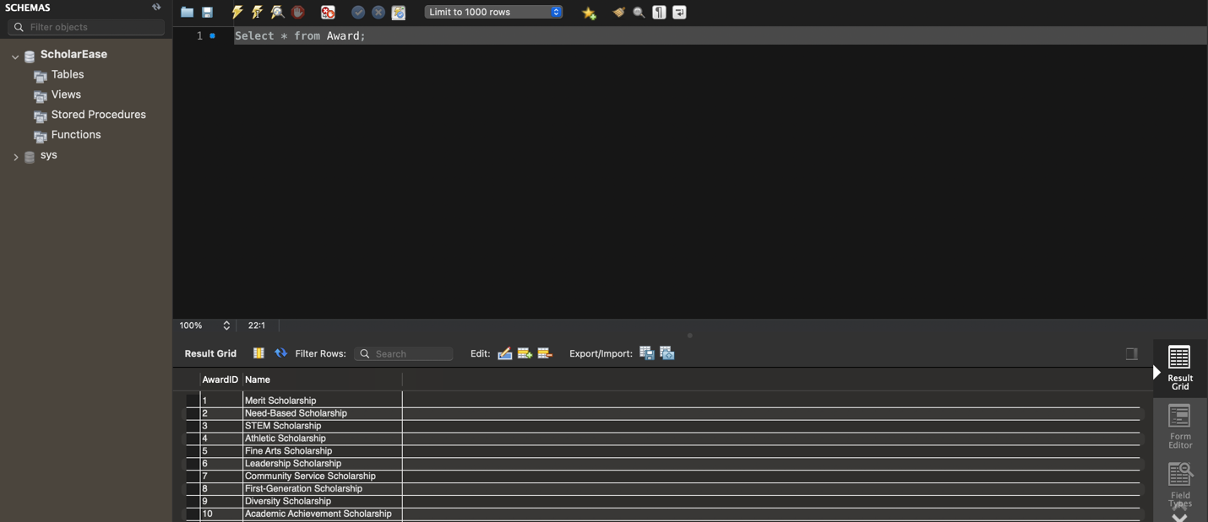

Institution Table:

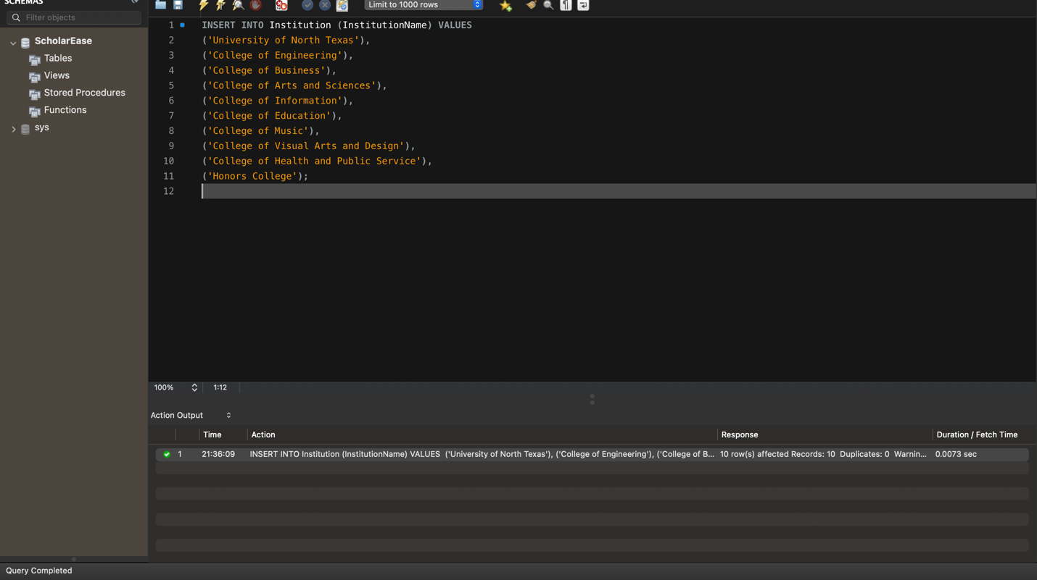

Displaying the data : 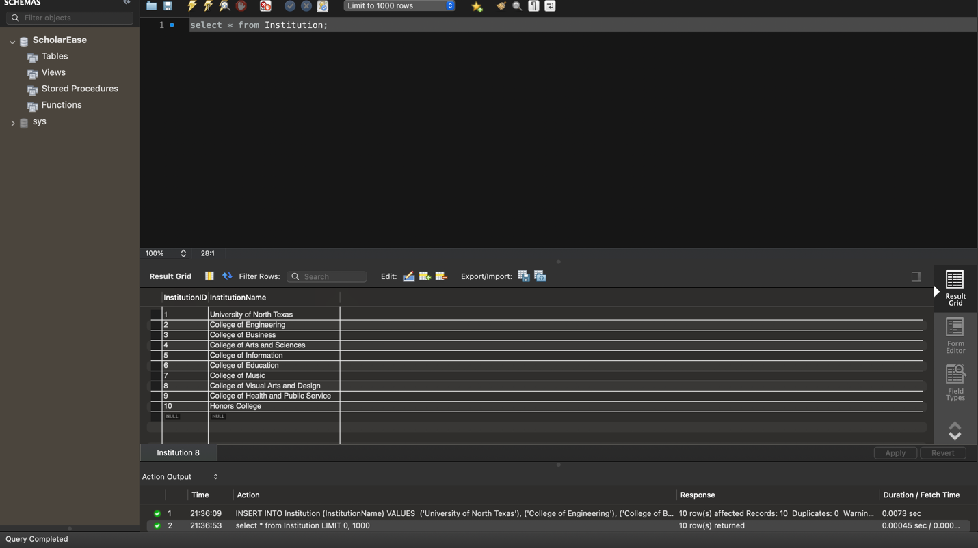

Student Table : INSERT INTO Student (StudentName, StudentAddress, StudentEmail, DepartmentID) VALUES

('John Doe', '123 Main St, Denton, TX', 'john.doe@myunt.com', 1),

('Jane Smith', '456 Elm St, Denton, TX', 'jane.smith@myunt.com', 2),

('Michael Johnson', '789 Oak St, Denton, TX', 'michael.johnson@myunt.com', 3),

('Emily Wilson', '101 Pine St, Denton, TX', 'emily.wilson@myunt.com', 4),

('Christopher Lee', '234 Maple St, Denton, TX', 'christopher.lee@myunt.com', 5),

('Sarah Brown', '567 Cedar St, Denton, TX', 'sarah.brown@myunt.com', 6),

('Daniel Taylor', '890 Birch St, Denton, TX', 'daniel.taylor@myunt.com', 7),

('Jessica Martinez', '111 Spruce St, Denton, TX', 'jessica.martinez@myunt.com', 8),

('Matthew Anderson', '222 Walnut St, Denton, TX', 'matthew.anderson@myunt.com', 9),

('Lauren Garcia', '333 Sycamore St, Denton, TX', 'lauren.garcia@myunt.com', 10),

('David Rodriguez', '444 Pine St, Denton, TX', 'david.rodriguez@myunt.com', 11),

('Ashley Nguyen', '555 Elm St, Denton, TX', 'ashley.nguyen@myunt.com', 12),

('Joshua Hernandez', '666 Maple St, Denton, TX', 'joshua.hernandez@myunt.com', 13),

('Amanda Chavez', '777 Oak St, Denton, TX', 'amanda.chavez@myunt.com', 14),

('Brandon Kim', '888 Cedar St, Denton, TX', 'brandon.kim@myunt.com', 15),

('Rachel Miller', '999 Birch St, Denton, TX', 'rachel.miller@myunt.com', 16),

('Erica Patel', '121 Spruce St, Denton, TX', 'erica.patel@myunt.com', 17),

('Kevin Wright', '232 Walnut St, Denton, TX', 'kevin.wright@myunt.com', 18),

('Olivia Torres', '343 Sycamore St, Denton, TX', 'olivia.torres@myunt.com', 19),

('Jason Clark', '454 Pine St, Denton, TX', 'jason.clark@myunt.com', 20),

('Stephanie Baker', '565 Elm St, Denton, TX', 'stephanie.baker@myunt.com', 1),

('Tyler Lewis', '676 Maple St, Denton, TX', 'tyler.lewis@myunt.com', 2),

('Hannah Scott', '787 Oak St, Denton, TX', 'hannah.scott@myunt.com', 3),

('Natalie Perez', '898 Cedar St, Denton, TX', 'natalie.perez@myunt.com', 4),

('Jacob Hall', '909 Birch St, Denton, TX', 'jacob.hall@myunt.com', 5),

('Samantha Young', '121 Spruce St, Denton, TX', 'samantha.young@myunt.com', 6),

('Ryan Allen', '232 Walnut St, Denton, TX', 'ryan.allen@myunt.com', 7),

('Kelsey White', '343 Sycamore St, Denton, TX', 'kelsey.white@myunt.com', 8),

('Nicole Martin', '454 Pine St, Denton, TX', 'nicole.martin@myunt.com', 9),

('Jordan Garcia', '565 Elm St, Denton, TX', 'jordan.garcia@myunt.com', 10);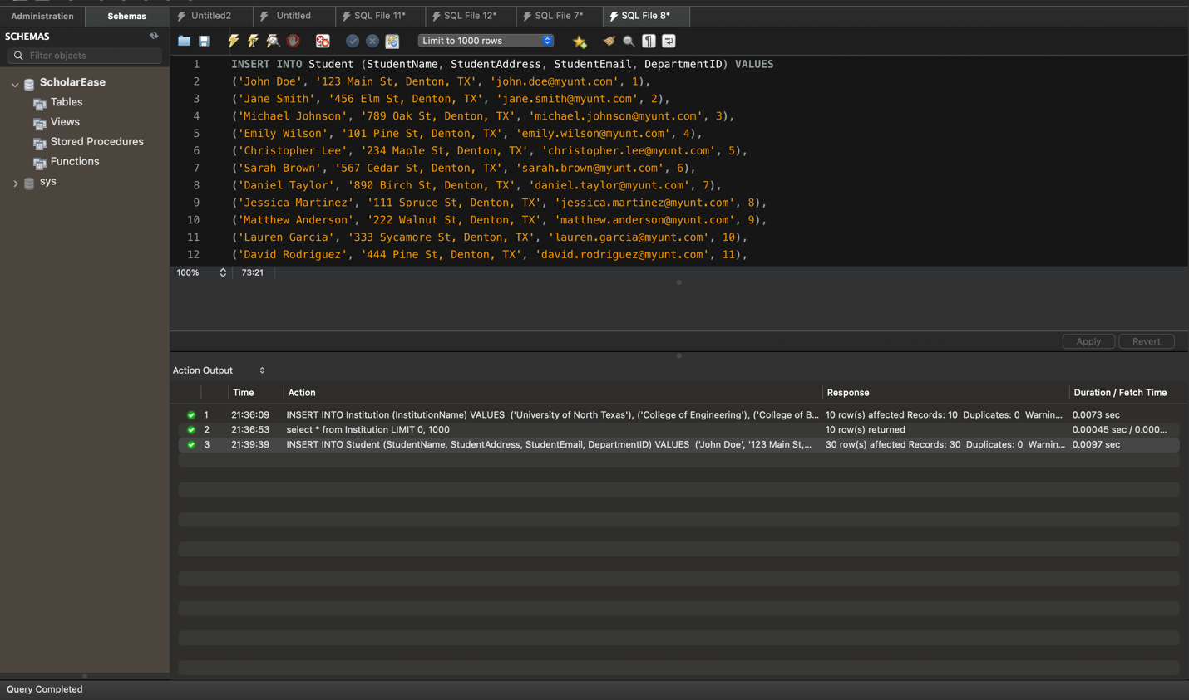

Result : 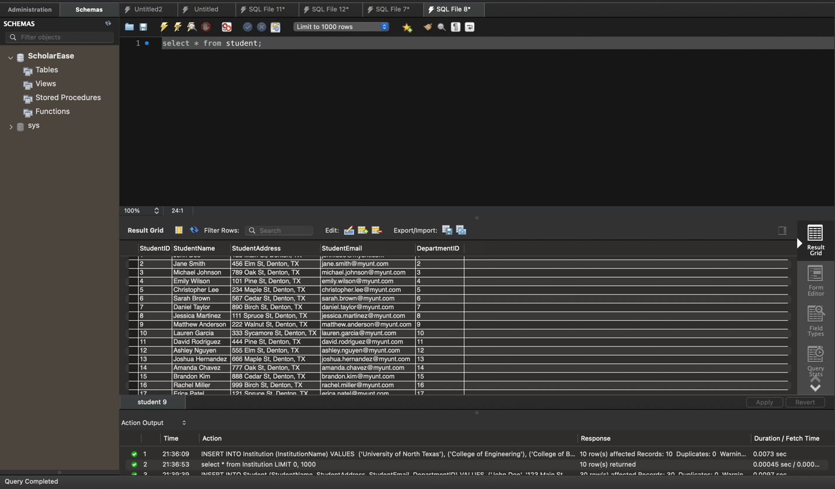

Scholarship Table: -- Insert data into Scholarship table

INSERT INTO Scholarship (AwardID, InstitutionID, Amount)

VALUES

(1, 1, 5000.00), -- Scholarship 1

(2, 2, 3000.00), -- Scholarship 2

(3, 1, 6000.00), -- Scholarship 3

(4, 4, 5500.00), -- Scholarship 4

(5, 3, 4000.00), -- Scholarship 5

(1, 5, 4500.00), -- Scholarship 6

(2, 1, 3200.00), -- Scholarship 7

(3, 2, 5800.00), -- Scholarship 8

(4, 3, 5200.00), -- Scholarship 9

(5, 4, 4300.00), -- Scholarship 10

(1, 2, 4700.00), -- Scholarship 11

(2, 3, 2900.00), -- Scholarship 12

(3, 4, 6100.00), -- Scholarship 13

(4, 1, 5400.00), -- Scholarship 14

(5, 5, 4200.00), -- Scholarship 15

(1, 4, 4800.00), -- Scholarship 16

(2, 5, 3100.00), -- Scholarship 17

(3, 3, 5900.00), -- Scholarship 18

(4, 2, 5300.00), -- Scholarship 19

(5, 1, 4100.00), -- Scholarship 20

(1, 3, 4600.00), -- Scholarship 21

(2, 4, 3300.00), -- Scholarship 22

(3, 5, 5700.00), -- Scholarship 23

(4, 1, 5600.00), -- Scholarship 24

(5, 2, 4400.00); -- Scholarship 25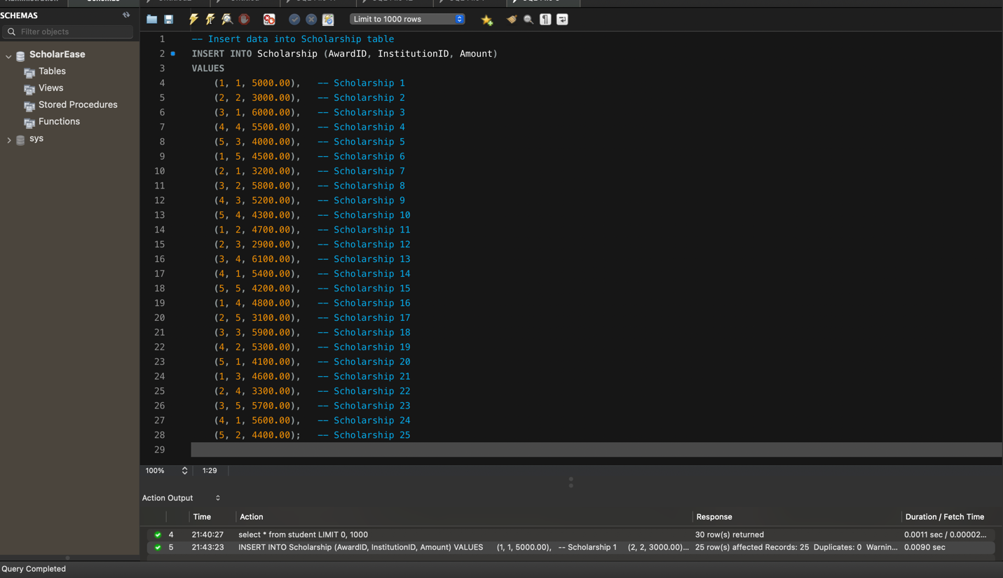

Displaying the data:

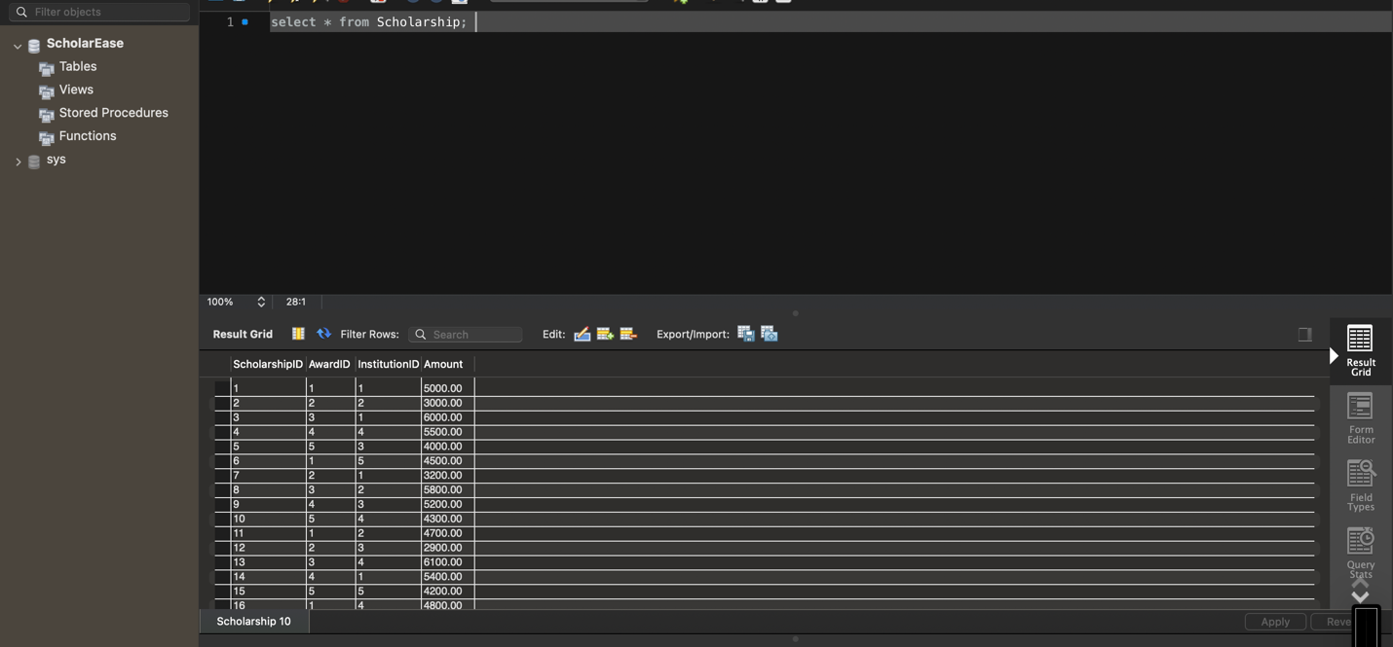

Application Table: -- Insert data into Application table

INSERT INTO Application (StudentID, ScholarshipID, ApplicationStatus)

VALUES

(1, 1, 'Pending'),

(2, 2, 'Approved'),

(3, 3, 'Rejected'),

(4, 4, 'Pending'),

(5, 5, 'Approved'),

(6, 6, 'Pending'),

(7, 7, 'Rejected'),

(8, 8, 'Pending'),

(9, 9, 'Approved'),

(10, 10, 'Rejected'),

(11, 11, 'Pending'),

(12, 12, 'Approved'),

(13, 13, 'Pending'),

(14, 14, 'Rejected'),

(15, 15, 'Pending'),

(16, 16, 'Approved'),

(17, 17, 'Pending'),

(18, 18, 'Rejected'),

(19, 19, 'Pending'),

(20, 20, 'Approved'),

(21, 21, 'Pending'),

(22, 22, 'Rejected'),

(23, 23, 'Pending'),

(24, 24, 'Approved'),

(25, 25, 'Pending');

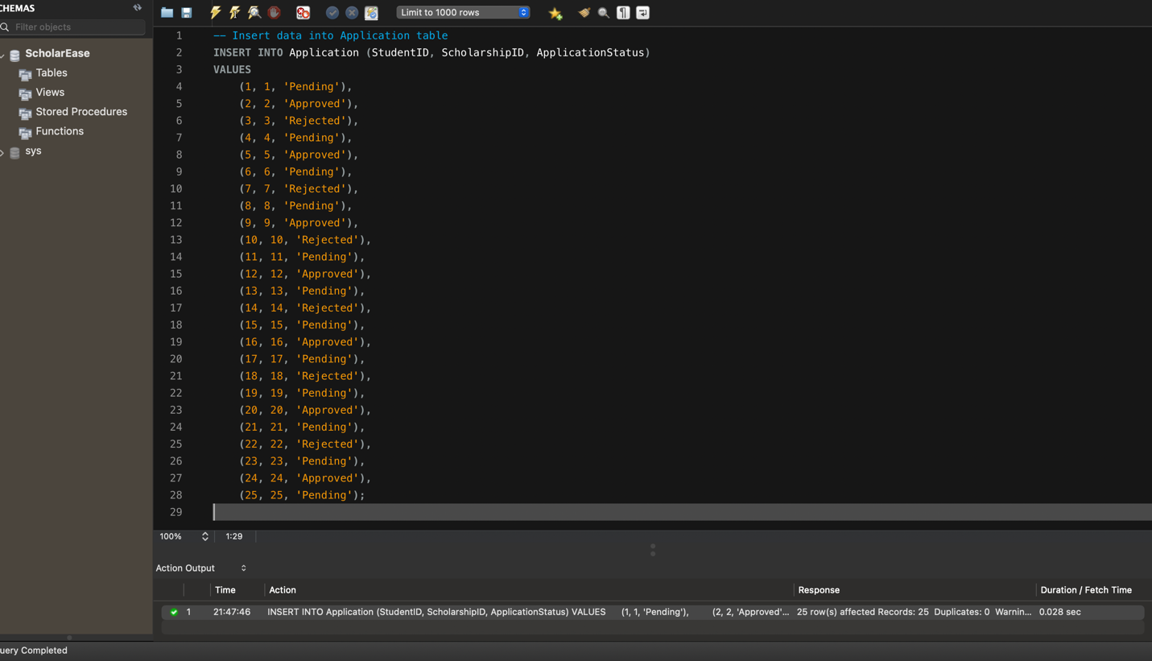

Displaying the data:

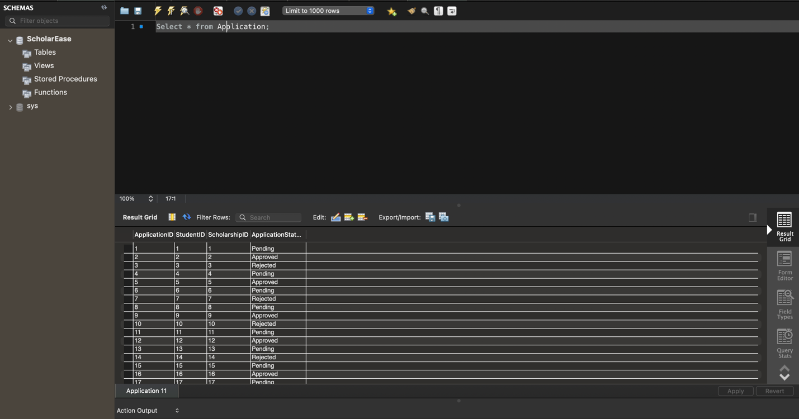

Criteria Table: -- Insert data into Criteria table

INSERT INTO Criteria (ScholarshipID, Description)

VALUES

(1, 'Must maintain a GPA of 3.5 or higher'),

(2, 'Active involvement in community service required'),

(3, 'Demonstrated financial need'),

(4, 'Leadership qualities and extracurricular activities preferred'),

(5, 'Essay submission required'),

(6, 'Must be pursuing a degree in STEM field'),

(7, 'Preference given to underrepresented minority students'),

(8, 'Demonstrated commitment to environmental conservation'),

(9, 'Strong academic record in relevant courses'),

(10, 'Demonstrated passion for social justice causes'),

(11, 'Exemplary performance in the arts'),

(12, 'Active participation in school sports'),

(13, 'Experience in entrepreneurship or innovation'),

(14, 'Preference given to first-generation college students'),

(15, 'Special consideration for students from rural areas'),

(16, 'Demonstrated proficiency in a foreign language'),

(17, 'Research experience in the chosen field of study'),

(18, 'Internship or work experience in related industry'),

(19, 'Leadership roles in student organizations'),

(20, 'Published academic or research papers'),

(21, 'Participation in specialized training programs'),

(22, 'Volunteer work with marginalized communities'),

(23, 'Innovative solutions to community challenges'),

(24, 'Demonstrated ability to overcome adversity'),

(25, 'Invention or patent in relevant field');

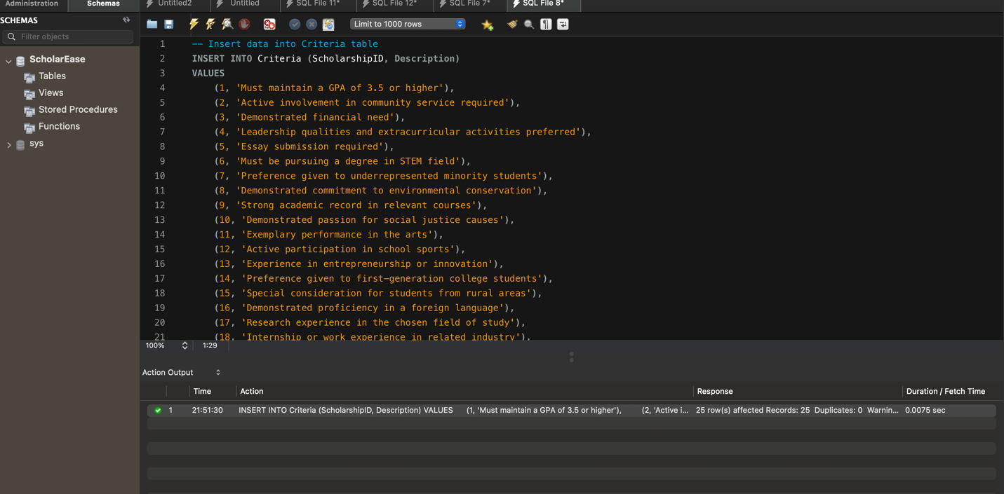

Displaying the result:

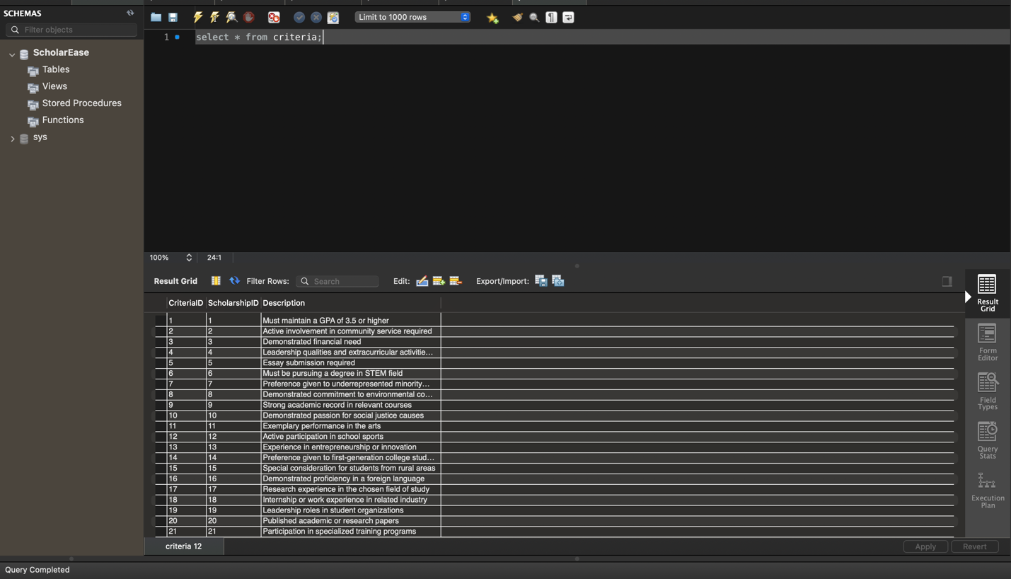

Review Table : -- Insert data into Review table

INSERT INTO Review (ScholarshipID, ApplicationID, ReviewerID, ReportID, Status)

VALUES

(1, 1, 1, 1, 'Pending'),

(2, 2, 2, 2, 'Approved'),

(3, 3, 3, 3, 'Rejected'),

(4, 4, 4, 4, 'Pending'),

(5, 5, 5, 5, 'Approved'),

(6, 6, 6, 6, 'Pending'),

(7, 7, 7, 7, 'Rejected'),

(8, 8, 8, 8, 'Pending'),

(9, 9, 9, 9, 'Approved'),

(10, 10, 10, 10, 'Rejected'),

(11, 11, 11, 11, 'Pending'),

(12, 12, 12, 12, 'Approved'),

(13, 13, 13, 13, 'Pending'),

(14, 14, 14, 14, 'Rejected'),

(15, 15, 15, 15, 'Pending'),

(16, 16, 16, 16, 'Approved'),

(17, 17, 17, 17, 'Pending'),

(18, 18, 18, 18, 'Rejected'),

(19, 19, 19, 19, 'Pending'),

(20, 20, 20, 20, 'Approved'),

(21, 21, 21, 21, 'Pending'),

(22, 22, 22, 22, 'Rejected'),

(23, 23, 23, 23, 'Pending'),

(24, 24, 24, 24, 'Approved'),

(25, 25, 25, 25, 'Pending'); 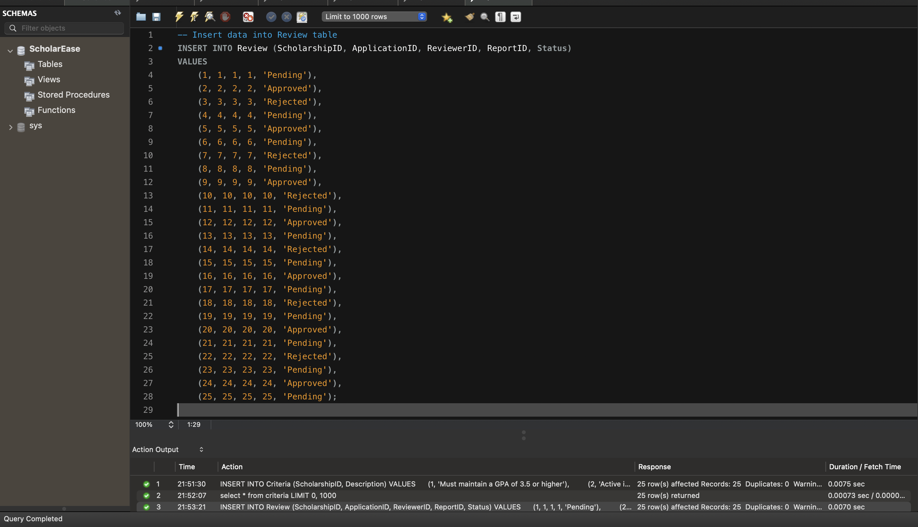

Displaying the result: 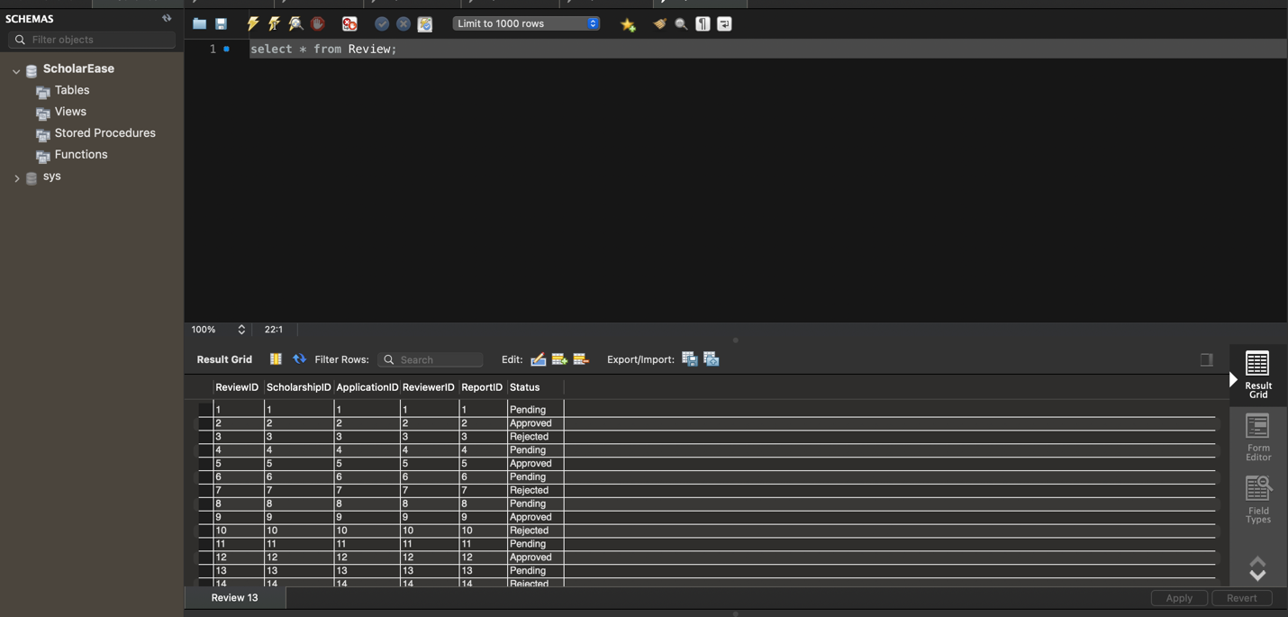

Disbursement Table:

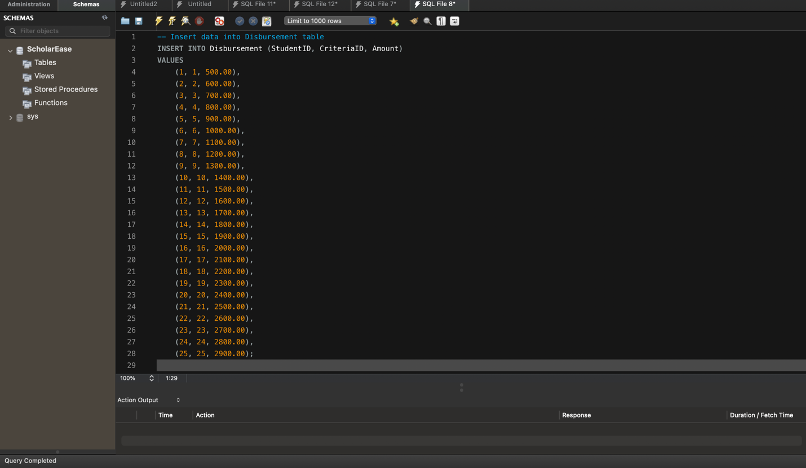

Displying the data : 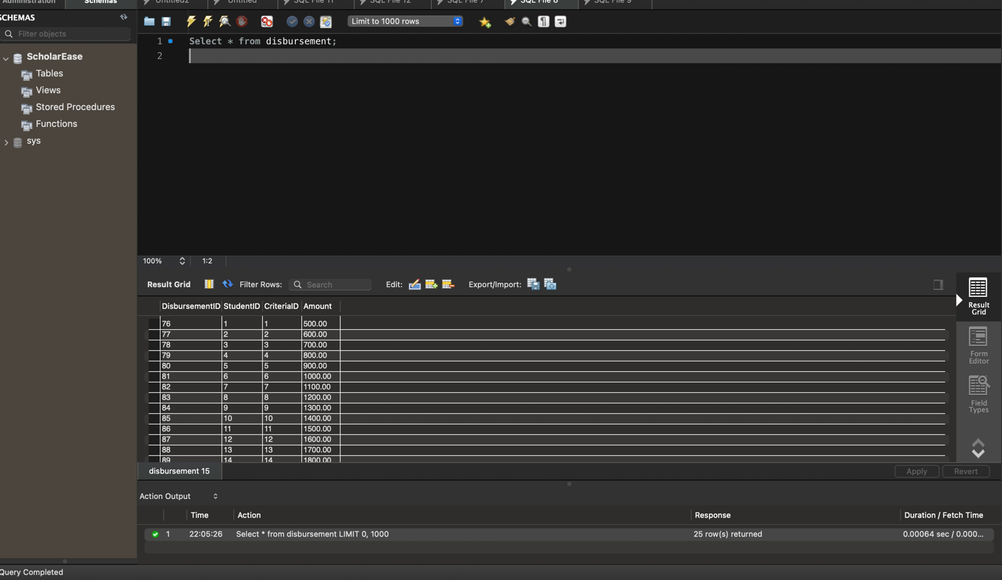

QUERIES/ DATA ANALYSIS Reports:

1) How many applications were approved/rejected for in each department

SELECT

d.DepartmentName,

SUM(CASE WHEN a.ApplicationStatus = 'Approved' THEN 1 ELSE 0 END) AS ApprovedApplications,

SUM(CASE WHEN a.ApplicationStatus = 'Rejected' THEN 1 ELSE 0 END) AS RejectedApplications

FROM

Department d

LEFT JOIN

Student s ON d.DepartmentID = s.DepartmentID

LEFT JOIN

Application a ON s.StudentID = a.StudentID

GROUP BY d.DepartmentName;

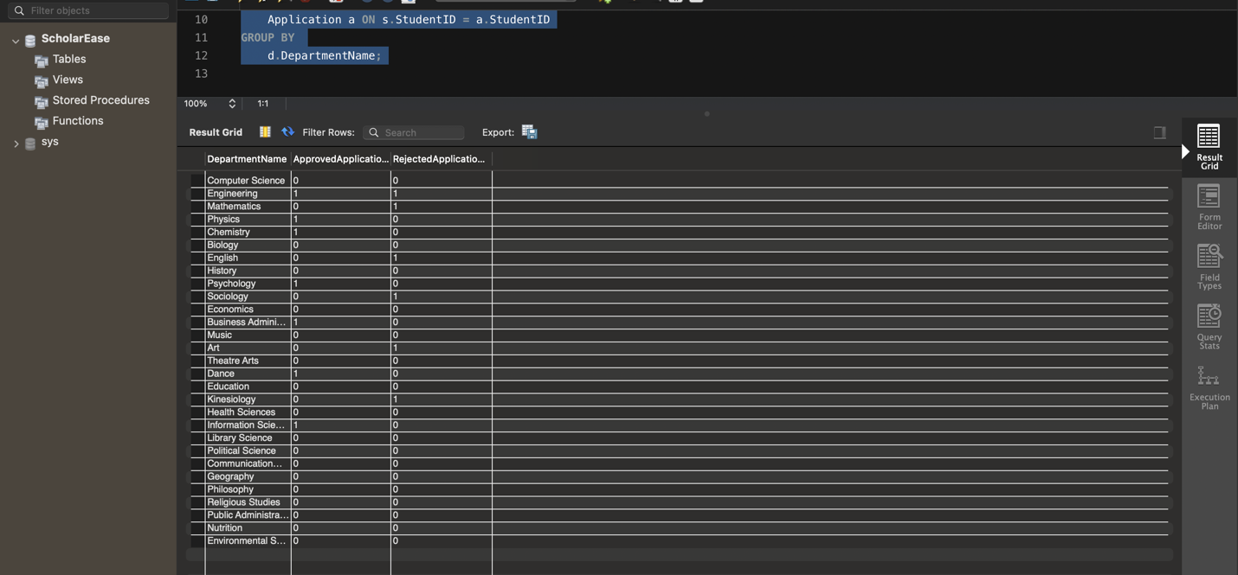

2. Write a SQL query to calculate the total disbursement amount for each department by summing the disbursement amounts associated with students in each department..

**QUERY :** WITH TotalDisbursementPerDepartment AS (

SELECT

s.DepartmentID,

d.DepartmentName,

SUM(db.Amount) AS TotalDisbursement

FROM

Disbursement db

INNER JOIN

Student s ON db.StudentID = s.StudentID

INNER JOIN

Department d ON s.DepartmentID = d.DepartmentID

GROUP BY

s.DepartmentID

)

SELECT

DepartmentName,

TotalDisbursement

FROM

TotalDisbursementPerDepartment

ORDER BY

DepartmentName;

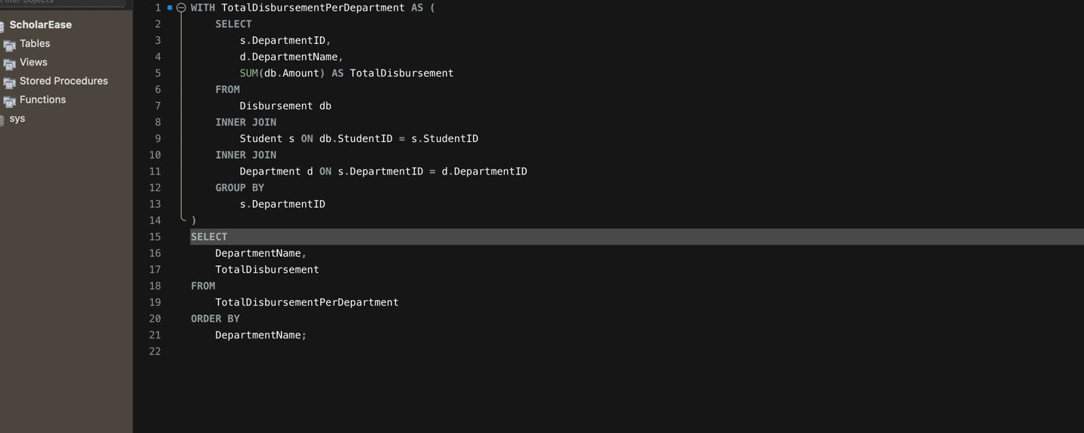

Result:



3)   
Write a query to retrieve the student name, department name, and scholarship criteria for each student who has applied for a scholarship. Ensure that only non-null scholarship criteria are included in the result set, and then order the results by student name.

Query: WITH StudentScholarshipCriteria AS (

SELECT

s.StudentName,

d.DepartmentName,

c.Description AS ScholarshipCriteria

FROM

Student s

INNER JOIN

Department d ON s.DepartmentID = d.DepartmentID

LEFT JOIN

Application a ON s.StudentID = a.StudentID

LEFT JOIN

Scholarship sch ON a.ScholarshipID = sch.ScholarshipID

LEFT JOIN

Criteria c ON sch.ScholarshipID = c.ScholarshipID

)

SELECT

StudentName,

DepartmentName,

ScholarshipCriteria

FROM StudentScholarshipCriteria

WHERE ScholarshipCriteria IS NOT NULL -- Exclude rows where ScholarshipCriteria is null

ORDER BY StudentName;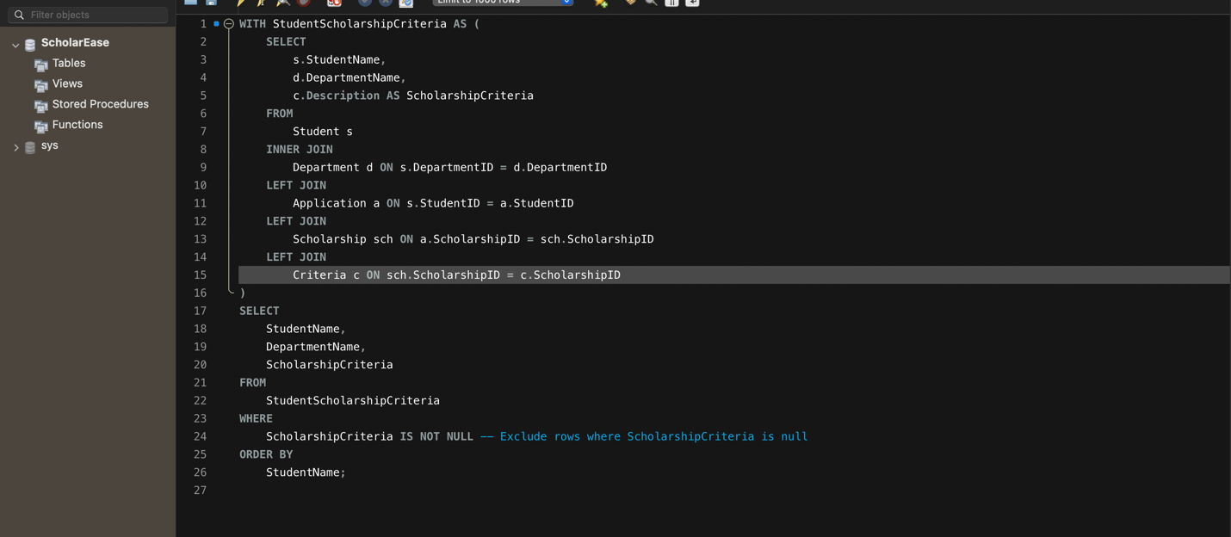

Result :

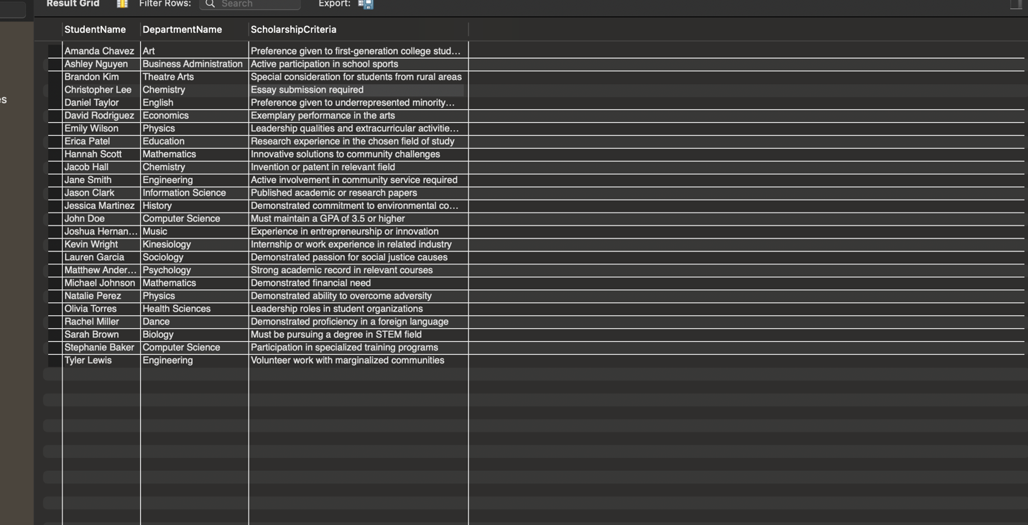

4. Write a query to retrieve information about students, including their name, email, department, latest application status, scholarship criteria, total amount disbursed, and total number of reviewed applications. Include students whose latest application status is 'Approved' or if they don't have any applications. Additionally, filter out students with a total amount disbursed greater than 1000. Finally, order the results by student ID.

Query : WITH RankedStudents AS (

SELECT

s.StudentID,

s.StudentName,

s.StudentEmail,

d.DepartmentName,

a.ApplicationStatus,

ROW_NUMBER() OVER (PARTITION BY s.StudentID ORDER BY a.ApplicationID DESC) AS RowNum

FROM

Student s

LEFT JOIN

Application a ON s.StudentID = a.StudentID

LEFT JOIN

Department d ON s.DepartmentID = d.DepartmentID

),

TotalDisbursement AS (

SELECT

s.StudentID,

SUM(d.Amount) AS TotalAmountDisbursed

FROM

Student s

LEFT JOIN

Disbursement d ON s.StudentID = d.StudentID

GROUP BY

s.StudentID

),

ReviewedApplications AS (

SELECT

StudentID,

COUNT(*) AS TotalReviewedApplications

FROM

Application a

INNER JOIN

Review r ON a.ApplicationID = r.ApplicationID

GROUP BY

StudentID

),

StudentScholarshipCriteria AS (

SELECT

s.StudentName,

d.DepartmentName,

c.Description AS ScholarshipCriteria

FROM

Student s

INNER JOIN

Department d ON s.DepartmentID = d.DepartmentID

LEFT JOIN

Application a ON s.StudentID = a.StudentID

LEFT JOIN

Criteria c ON a.ScholarshipID = c.ScholarshipID

)

SELECT

rs.StudentID,

rs.StudentName,

rs.StudentEmail,

rs.DepartmentName,

rs.ApplicationStatus,

ssc.ScholarshipCriteria,

COALESCE(td.TotalAmountDisbursed, 0) AS TotalAmountDisbursed,

COALESCE(ra.TotalReviewedApplications, 0) AS TotalReviewedApplications

FROM

RankedStudents rs

LEFT JOIN

StudentScholarshipCriteria ssc ON rs.StudentName = ssc.StudentName

LEFT JOIN

TotalDisbursement td ON rs.StudentID = td.StudentID

LEFT JOIN

ReviewedApplications ra ON rs.StudentID = ra.StudentID

WHERE

rs.RowNum = 1

AND (rs.ApplicationStatus = 'Approved' OR rs.ApplicationStatus IS NULL)

AND td.TotalAmountDisbursed > 1000

ORDER BY

rs.StudentID;

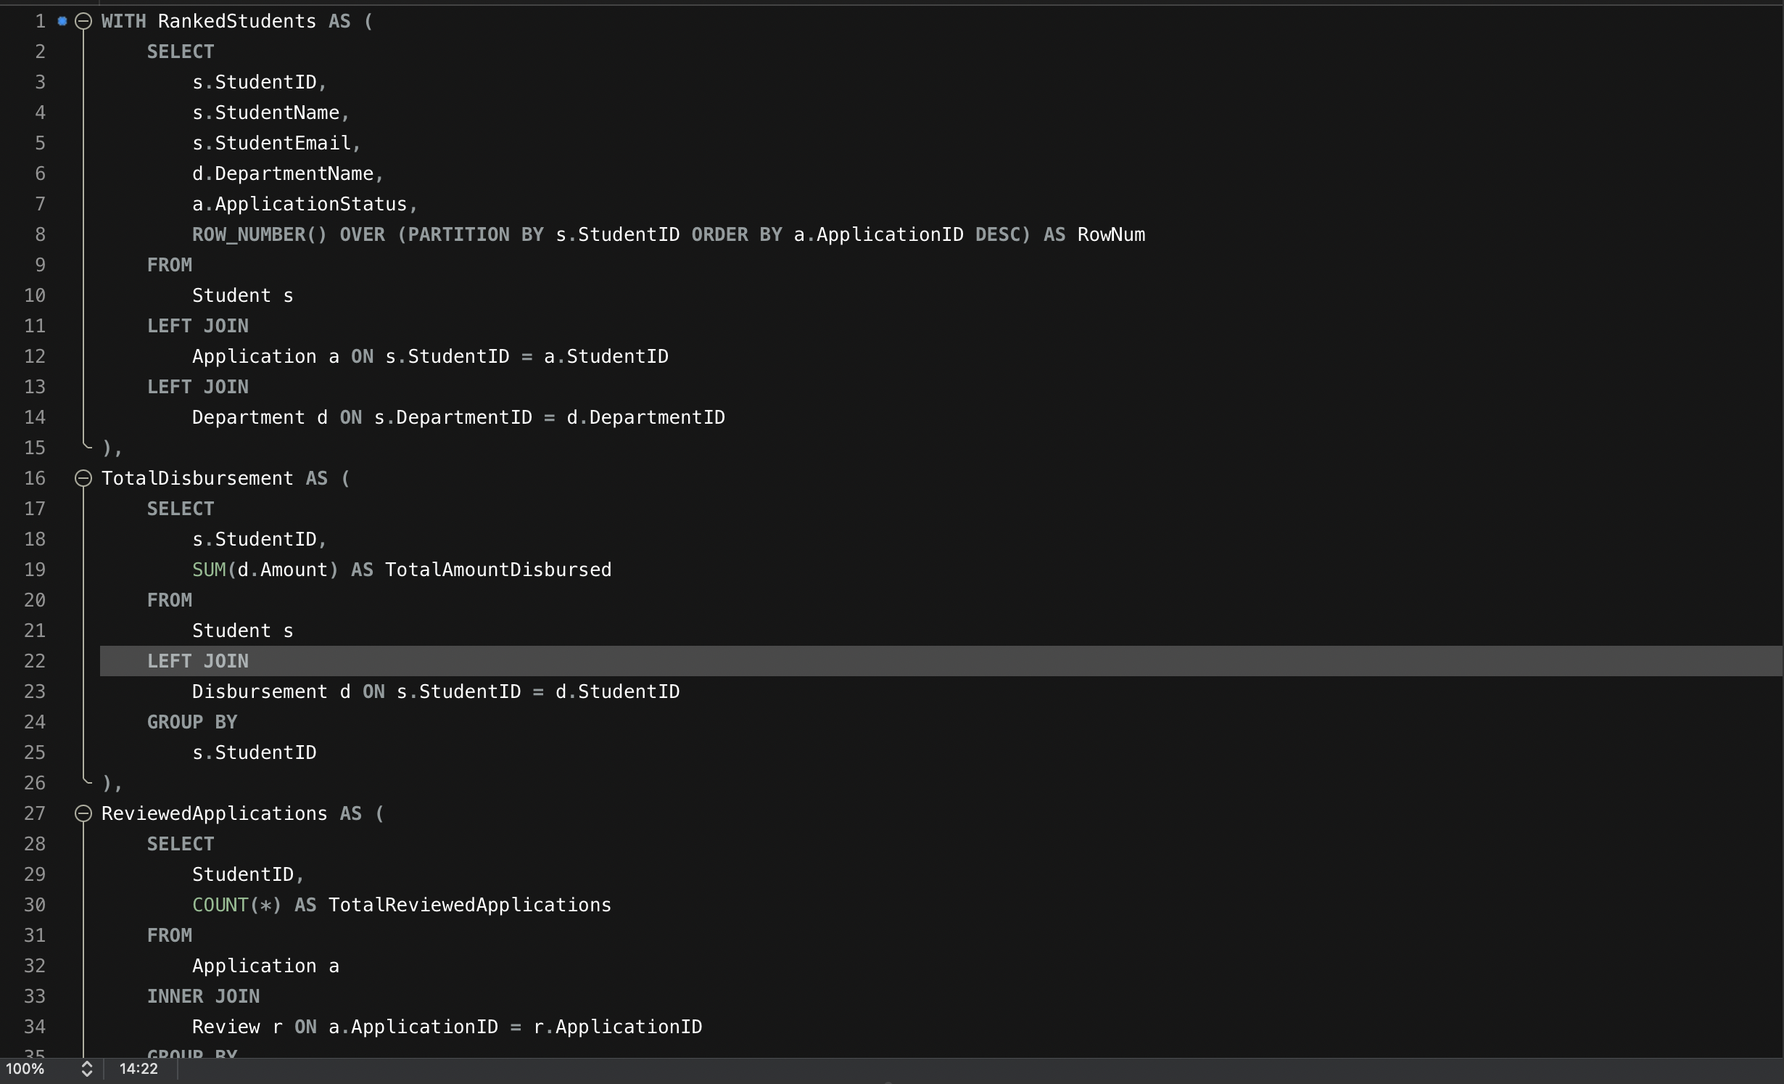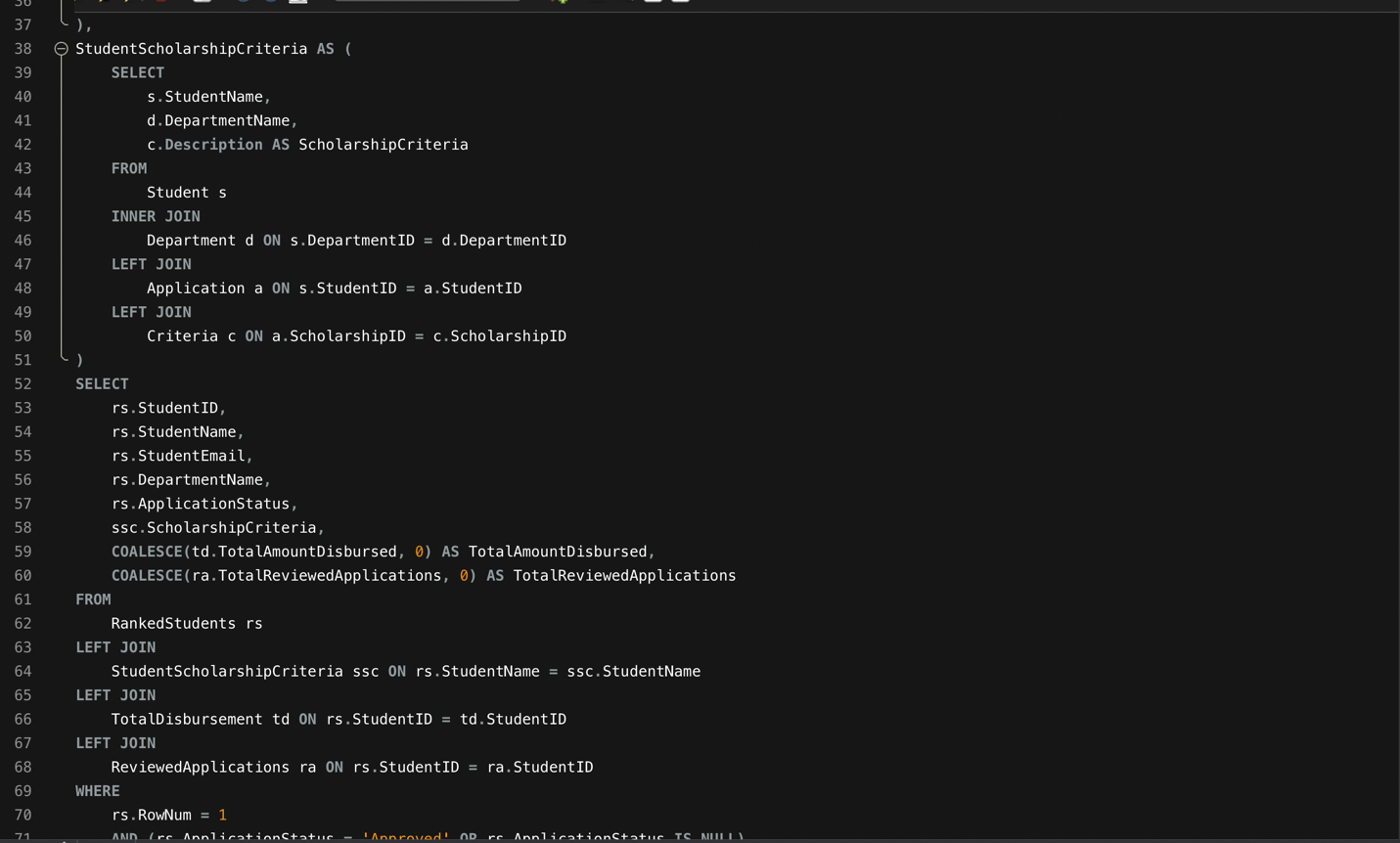

Result:

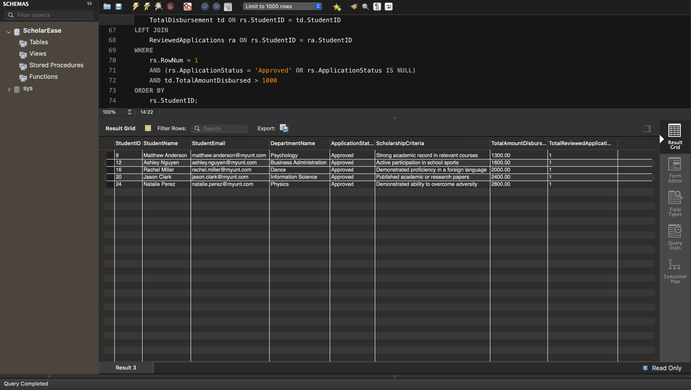

5. Write a query to retrieve information about scholarships along with the names of students who have applied for them, their application statuses, and the departments they belong to. Include only those scholarships that have received applications and sort the results by scholarship name.

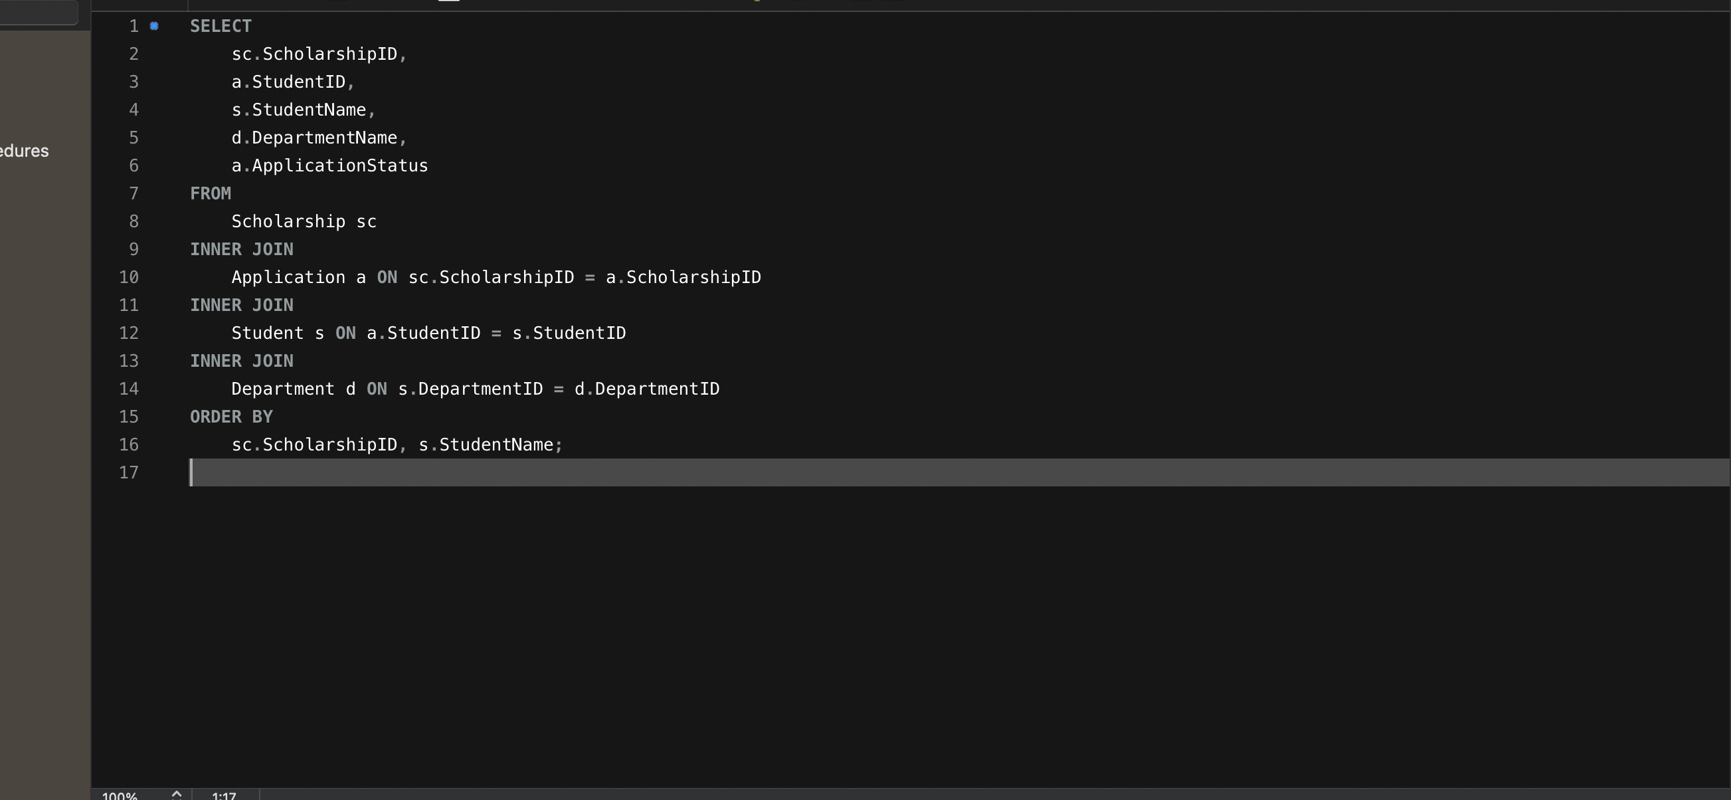

Result : 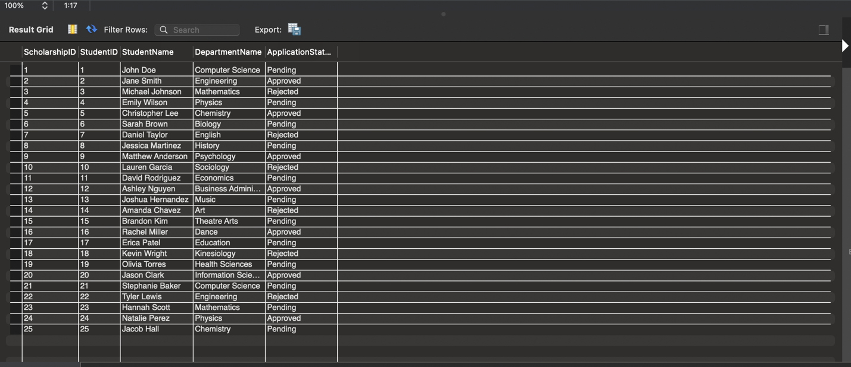

6: Write a SQL query to retrieve information about ranked students, including their student ID, name, email, department, latest application status, scholarship criteria, total amount disbursed, and total number of reviewed applications. Ensure that the results only include non-null values for each attribute and are ordered by student ID."

With RankedStudents AS (

SELECT

s.StudentID,

s.StudentName,

s.StudentEmail,

d.DepartmentName,

a.ApplicationStatus,

ROW_NUMBER() OVER (PARTITION BY s.StudentID ORDER BY a.ApplicationID DESC) AS RowNum

FROM

Student s

LEFT JOIN

Application a ON s.StudentID = a.StudentID

LEFT JOIN

Department d ON s.DepartmentID = d.DepartmentID

), TotalDisbursement AS (

SELECT

s.StudentID,

SUM(d.Amount) AS TotalAmountDisbursed

FROM

Student s

LEFT JOIN

Disbursement d ON s.StudentID = d.StudentID

GROUP BY

s.StudentID

), ReviewedApplications AS (

SELECT

a.StudentID,

COUNT(*) AS TotalReviewedApplications

FROM

Application a

INNER JOIN

Review r ON a.ApplicationID = r.ApplicationID

GROUP BY

a.StudentID

), StudentScholarshipCriteria AS (

SELECT

s.StudentName,

d.DepartmentName,

c.Description AS ScholarshipCriteria

FROM

Student s

INNER JOIN

Department d ON s.DepartmentID = d.DepartmentID

LEFT JOIN

Application a ON s.StudentID = a.StudentID

LEFT JOIN

Criteria c ON a.ScholarshipID = c.ScholarshipID

)

SELECT

rs.StudentID,

rs.StudentName,

rs.StudentEmail,

rs.DepartmentName,

rs.ApplicationStatus,

ssc.ScholarshipCriteria,

COALESCE(td.TotalAmountDisbursed, 0) AS TotalAmountDisbursed,

COALESCE(ra.TotalReviewedApplications, 0) AS TotalReviewedApplications

FROM

RankedStudents rs

LEFT JOIN

StudentScholarshipCriteria ssc ON rs.StudentName = ssc.StudentName

LEFT JOIN

TotalDisbursement td ON rs.StudentID = td.StudentID

LEFT JOIN

ReviewedApplications ra ON rs.StudentID = ra.StudentID

WHERE

rs.RowNum = 1

AND rs.StudentName IS NOT NULL

AND rs.StudentEmail IS NOT NULL

AND rs.DepartmentName IS NOT NULL

AND rs.ApplicationStatus IS NOT NULL

AND ssc.ScholarshipCriteria IS NOT NULL

AND td.TotalAmountDisbursed IS NOT NULL

AND ra.TotalReviewedApplications IS NOT NULL

ORDER BY

rs.StudentID;

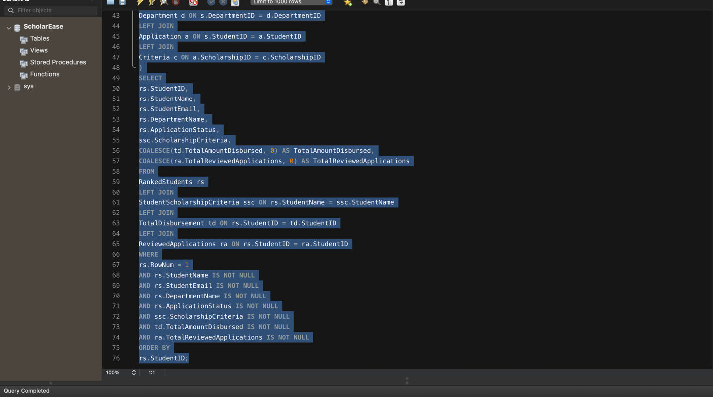

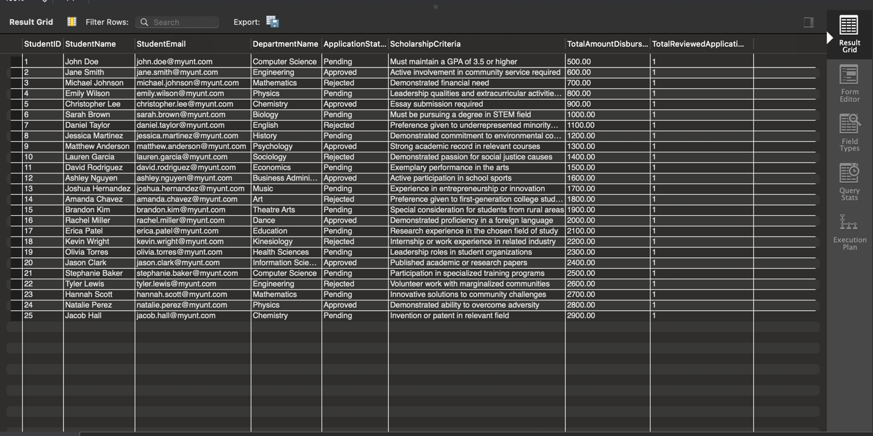

7. Write a SQL query to retrieve the top 3 criteria that have the highest total scholarship amount disbursed.

WITH CriteriaTotalDisbursement AS (

SELECT

c.CriteriaID,

c.Description AS CriteriaDescription,

SUM(s.Amount) AS TotalDisbursedAmount

FROM

Criteria c

INNER JOIN

Scholarship s ON c.ScholarshipID = s.ScholarshipID

GROUP BY

c.CriteriaID, c.Description

)

SELECT

CriteriaID,

CriteriaDescription,

TotalDisbursedAmount

FROM

CriteriaTotalDisbursement

ORDER BY

TotalDisbursedAmount DESC

LIMIT 3;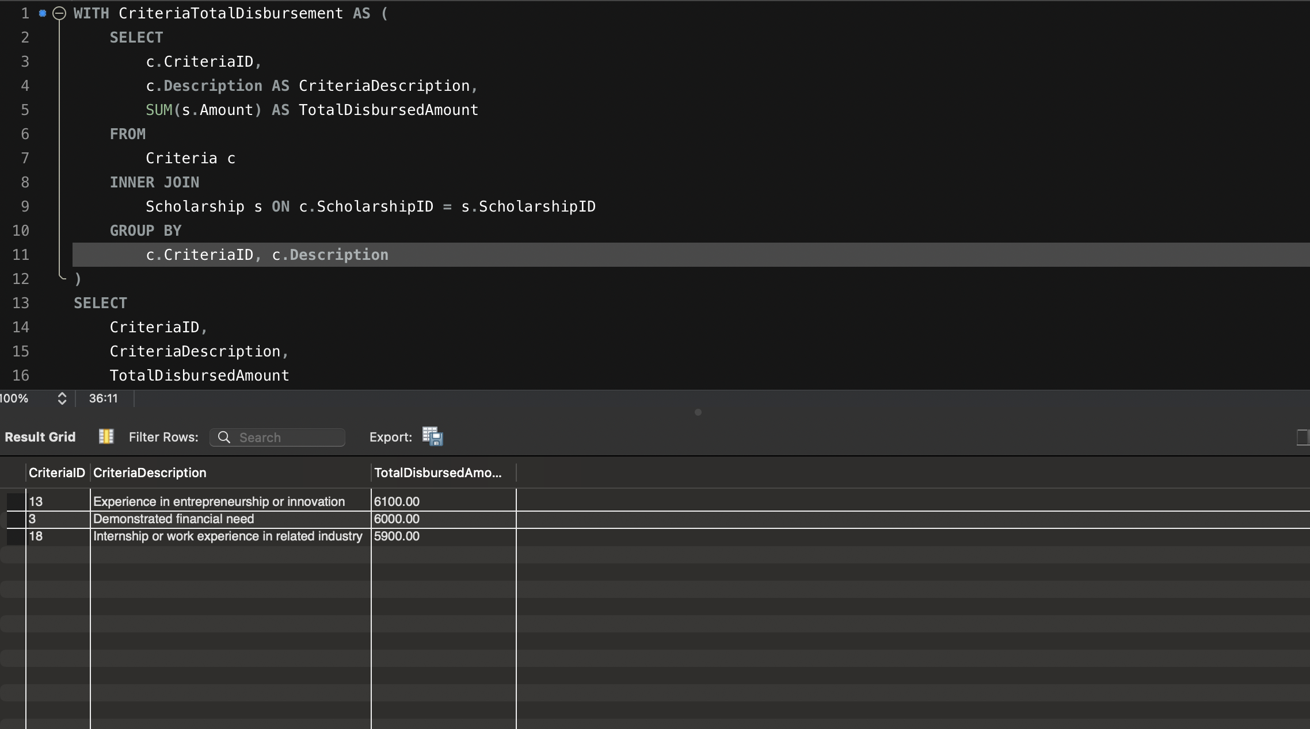

8. Write a SQL query to retriveve the students who have been awarded scholarships from the Biology and Computer Sciences departments